Functional and technical brief

DIANE ANAESTHESIA
DIANE ICU

Warning

© (Copyright BOW Medical, 2018)
All rights reserved. Any reproduction by any means, even partial, is prohibited without prior written permission from Bow Medical. Copying by means of xerography, photography, film, magnetic media or other means, constitutes an infringement liable to the penalties provided for in particular by the French copyright protection laws of 11 March 1957 and 3 July 1995.
Limits of liability and warranty. Bow Medical used its best endeavours to craft this document. Bow Medical assumes no liability for the reliability or completeness of its contents. BOW Medical shall not be held liable for this document’s suitability for any purpose and in no event shall it be held liable for any loss, profit or any other commercial damages, including but not limited to special, incidental, consequential or other damages.
Registered trademarks. All known information on the trademarks for the products, services and companies mentioned herein has been provided. Bow Medical assumes no liability regarding the completeness and interpretation of said information. All other brand and product names used herein are trademarks or trade names of their respective owners.

Table of contents
1. INTRODUCTION 6
2. GÉNÉRALITÉS DE LA SUITE LOGICIELLE DIANE 6
2.1 Caractéristiques générales 6
2.2 Paramétrage 7
2.3 Fonctions complémentaires 8
2.4 Ergonomie 9
2.5 Outil de statistiques 9
2.6 Outil de requêtes 10
2.7 Revue de cas, enseignement 10
2.8 Recherche Multi critères 10
2.9 Tableau de bords périodiques 11
2.10 Utilisation hors connexion avec le SIH 11
2.11 Sécurité 11
2.12 Authentification 12
2.13 Traçabilité 12
2.14 Habilitation 12
2.15 Edition du dossier médical 12
2.16 Archivage 13
2.17 Capacité d’évolution du logiciel 13
3. DOSSIER DE PARAMÉTRAGE 14
4. INTERFACES AVEC LE S.I.H. 14
4.1 Les interfaces 14
4.2 Fonctionnement interne 16
5. INFORMATISATION DE LA RÉANIMATION 18
5.1 Présentation fonctionnelle 18
5.1.1 Charte graphique, vue service et navigation 18
5.1.1 Etiquette patient / identitovigilance 20
5.1.2 Vue générale / surveillance 21
5.1.3 Balance liquidienne 22
5.1.4 Procédure dégradée / Mode déconnecté 22
5.1.5 Dossier patient 22
5.1.6 Dossier médical 23
5.1.7 Paramédical / Transmissions 24
5.1.8 Prescriptions 25
5.1.8.1 Validation pharmaceutique 26
5.1.8.2 Médicaments hors GHS / Antibiotique 27
5.1.9 Prescriptions non médicamenteuses 27
5.1.10 Plan de soin 27
5.1.11 Matériel / pansements / Schéma 28
5.1.12 Pancartes 28
5.1.13 Connexion avec les dispositifs médicaux 30
5.1.14 Laboratoire 30
5.1.15 Interface graphique et format de visualisation 31
5.1.16 Actes marqueurs / PMSI 31
5.1.17 Compte-rendu 32
5.1.18 Clôture du dossier 32
5.1.19 Tableau de bord 32
6. INFORMATISATION DE L’ANESTHÉSIE 33
6.1 Charte graphique et navigation 33
6.1.1 Charte graphique, vue service et navigation 33
6.2 Identitovigilance 33
6.3 Consultation d’anesthésie 34
6.3.1 Consultation antérieure 35
6.3.2 Prescription médicamenteuse 35
6.3.3 Examens de laboratoire 36
6.3.4 Conclusion de la CPA 36
6.3.5 CR d’examens antérieurs / ordonnances 36
6.3.6 Informations données aux patients 37
6.4 Visite pré anesthésique / mobilité 37
6.4.1 Liste de patients 37
6.5 Per opératoire 37
6.5.1 Ouverture de salle / éléments importants 37
6.5.2 Contenue de la feuille d’anesthésie 38
6.5.2.1 Affichage 38
6.5.3 Administration médicamenteuse 39
6.5.4 Protocoles 39
6.5.5 Prescription post-opératoire 39
6.5.6 Sortie de salle 40
6.6 Connexion avec les dispositifs médicaux 40
6.7 Affichage et visualisation 40
6.8 Balance liquidienne 41
6.9 SSPI 41
6.9.1 Sortie SSPI 42
6.10 Compte-rendu 42
6.11 Clôture du dossier 42
6.12 L’ambulatoire 42
7. ARCHITECTURE TECHNIQUE 43
7.1 Généralités 43
7.2 Serveur de base de données 43
7.2.1 Intégration de document 44
7.3 Serveur d’interfaces 44
7.3.1 Comptes FTP 45
7.4 Installation 45
7.5 Mises à jour 45
7.6 Les postes de travail 46
7.6.1 L’architecture 46
7.6.1.1 Le DiaServeur 47
7.6.1.2 Cache local 47
7.6.2 Les postes principaux 48
7.6.3 Les postes miroirs 48
7.6.3.1 Postes miroirs – vue technique 49
7.6.3.1.1 Chargement des dossiers 50
7.7 Installation dans les services 50
7.7.1 Chambre de réanimation 50
7.7.2 USC 51
7.7.3 Salle d’intervention 51
7.7.4 SSPI 52
7.8 Connexion aux appareils médicaux 53
7.8.1 Plusieurs solutions disponibles 54
7.8.2 Du côté de Diane 54
8. MODE DÉCONNECTÉ / CONTINUITÉ DE SERVICE 57
8.1 Poste client 58
9. PROTECTION DU LOGICIEL 60
9.1 Droit d’auteur 60
9.2 Restriction des droits 60
9.3 Réservation de droits 61

INTRODUCTION
DIANE is an EMR software suite intended for ICUs, anaesthetists and OB-GYNs.
As DIANE ICU, Anaesthesia and OB-GYN share the same database, all information entered in any of the modules will automatically be populated to the others.
DIANE Anaesthesia is deployed in over 2500 operating theatres. DIANE ICU, which Bow Medical began developing in 2011, is used to manage 510 ICU beds of all types in both public and private care settings throughout France, including Saint Louis Teaching Hospital in Paris, Reims Teaching Hospital, Marie Lannelongue Medical-Surgical Centre, Métropole Savoie Hospital, Montélimar Hospital and clinics operated by Ramsay GdS and OC Santé.
The main technical and functional advantages of DIANE Anaesthesia and ICU are:
- Interoperability (270 interface flows with 57 software companies);
- Integration of medical devices (410 different types used in ICUs, CCUs, RRs and OSs);
- Usability designed for ICUs of all types;
- Designed for offline use (in case of unexpected server failures);
- Fully configurable by its key users,
- Comes pre-configured and geared to a facility’s specific needs before being rolled out;
- Can be used anywhere anaesthetists-intensivists and their teams practice;
- A unit record that can be used by doctors, nurses, physiotherapists, dieticians, social workers, specialists, correspondents and other professionals;
- An approved, stable solution that has been used for 20 years and deployed in more than 150 facilities;
- Developed in France and sold by a French SME.

GENERAL INFORMATION ABOUT THE DIANE SOFTWARE SUITE

General features
Simultaneous access is guaranteed by a system of primary/secondary sessions that allows read/write operations to patient records to be performed simultaneously and securely from multiple computers. Updates are synchronised in real time without users having to refresh the screen when they access a particular record.
Idle user sessions are automatically logged out to protect patient confidentiality. Sessions are re-opened by entering a password. The information on the screen will be that displayed before being the session was timed out.
Integrating DIANE into an HIS allows patients’ health histories to be taken into consideration in relation to a hospital’s other business software.
DIANE is always open and accessible 24/7.
DIANE is recognised for its ease of use, intuitive design, usability and user friendliness.
Because it is installed directly on user computers (client servers), DIANE guarantees fast, minimal response times: fast connection (whether for one or multiple users), swift jumping from one screen to another, quick loading of pages and tabs. Response times are affected by the volume of data in each patient record. For example, because data are collected from medical devices less than once every 10 seconds, stays of longer than 150 days produce staggering amounts of data. DIANE reloads only useful data and systematically stores non-useful data.
Response times on all computers are identical under the same conditions regardless of the day of the week, time of day, number of simultaneous users and network conditions.
DIANE interfaces with 410 different biomedical devices used in anaesthesia and intensive care units (monitors, ventilators, dialysis machines, etc.).
DIANE features maximum automaticity, is configurable (configuration and integration of new devices, choice of views, easy and quick creation of new variables and additional input screens, etc.) and can be set so that certain types of data must be entered according to predefined situations.
Its availability and architecture mean that information can be easily found in the database.
Although the data operating system is open-source, various processes are implemented to ensure that the privacy of patient data is not compromised (anonymization of records in high-traffic areas, screen timeout after a certain amount of time, automatic logout of idle sessions).
DIANE enables certain types of data (particularly medical device parameters) to be validated electronically.
Data is backed up automatically and securely for each individual primary computer, the database and the servers. In addition, vital patient data (such as medication orders) are systematically saved in PDF format so that they are available in case the application crashes.
Interventions (type, time logged, time performed and by whom) are tracked in full and at all times.
DIANE’s interface and consistency with hospital information systems are a priority for obtaining and sharing information, particularly regarding the rest of the patient’s journey.

Configuration
DIANE Anaesthesia and DIANE ICU can be fully configured by key users (non-IT specialists). The configuration tool used is simple and intuitive.
Key users receive the training needed to teach health professionals the skills they will need to use the configuration tool without any outside assistance (organization of tab contents, protocols, dosage favourites, etc.).
Depth of configuration of the system’s various components:
As the system is configurable (configuration and integration of new devices, choice of views, easy and quick creation of new variables, additional input screens, etc.), it can be set during configuration so that certain types of data must be entered according to predefined situations.
- Legal entity
- Facility
- Unit
- Technical support centre
- Room
- Bed
- User

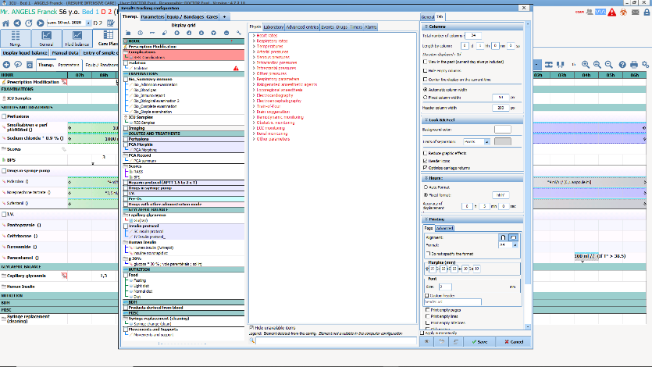
DIANE features multiple configuration levels:
- Protocols
- Questionnaires
- Document templates
- HMI (per component and/or tab)
- Lists
- Favourites
- Favourite medication orders, care orders
- Alarms
- Procedure nomenclatures
- Incident nomenclatures
- Display of paraclinical parameters
- Collection of admission/discharge data
- Favourites: We provide a set of favourites and marker procedures that can be subsequently changed.
- Favourite typical dosages. You can create your own favourites and, depending on the user centre, assign them as ‘public’ or ‘individual’.
- Creation of protocol favourites.
Depending on their profile, users have access to very advanced configuration possibilities that allow them to adapt the software to the organisational needs of their specific unit. Configurators are informed of the consequences of changes to any parameters (alert messages).
The software’s configuration transactions are highly intuitive and offer a satisfactory level of user friendliness. In addition, they allow configurators to become fully independent and adapt it to the needs of their unit without having to call on Bow Medical.
The software allows routes of administration to be configured (example for drips: doses, dissolution and administration solvent, volume, etc.) so as to facilitate the medication orders.

Additional functions
- Context-sensitive decision support: when a trigger is entered in DIANE, information is entered either automatically or with the doctor’s consent. For example, entering ‘asthma’ will automatically call up an asthma description sheet. A new edition of an examination field or a specific test or medication order to be confirmed or edited following the addition of this new trigger.
- Consistency check
- Alerts: incomplete records, drug interactions, patient infection levels (e.g., MRB, Staphylococcus).
- Automatic detection of interactions and contraindications
- Auto-teaching
- Configurable rule engine: the software is fully configurable.
- Knowledge base population, integration of unit protocols, access to the database interface, sites and thesaurus.
- Access to external databases (Vidal, BCB, SRLF).

Usability
DIANE was developed in collaboration with Evalab laboratory and a committee of anaesthetist-intensivists to provide a set of input tools that can be adapted to all users:
- Mouse, keyboard
- Predictive text
- Input tree
- Drop-down lists
- Check boxes
- Autocomplete of date fields
- Comment box
- Radio buttons
- Multiple entry
- Intelligence engine
Although touch features may be used to enter data in real time in the views or grids, DIANE was primarily developed for use with a keyboard and mouse.
- Automation of repetitive tasks
- Access to print functions
- Context menus
- Autocomplete
- Autofill
- Keyboard shortcuts
- DIANE supports touch functions on tablet PCs with touch screens, especially for reading information or records. Nevertheless, we strongly advise using a mouse and keyboard when prescribing and documenting the care plan.
- Bar code reading by fields containing bar codes.
Many rules can be applied to form fields (calculation possibilities, conditional values, etc.): tick in the tree structure, direct manual entry or in addition. Changes of dosage in medication order grids are calculated automatically and can be changed manually.
Pregenerate documents and reports automatically: DIANE ICU features a database that suggests form letters, diagrams and other documents in Word format so that data extracted automatically from patient records can be tailored as needed.
Healthcare teams can expand the document database by adding other documents to patient records. DIANE comes standard with a library of around 150 documents that we customize in advance with your facility’s logo and information.

Statistics tool
DIANE automatically collects all structured data and codes. As DIANE is fully configurable, the data collected are customised to your teams’ needs.
Analyses and data are stored on your intranet and can be edited and used as often as needed.
Regarding availability, DIANE is a client/server solution. The database is installed on your intranet so that all users within your facility can access and use it.

Query tool
The application comes with a built-in query system. The database contains queries that can be completed by doctors on an ad hoc basis using the query tool provided. We also provide online training and support for executing queries.
The query tool comes standard with the various statistical queries recommended by the French Society of Anesthesia and Intensive Care Medicine (SFAR) and the French Society of Intensive Care (SRLF) and contains some 50 other queries usually requested by centres.
Predefined queries are accessible from any computer running DIANE.
Users can use the database to carry out the analyses they wish to perform. The query tool is simple and intuitive and data can be exported to Excel.
In addition, other queries based on the same four basic principles used can be executed even by users who do not possess any special computer skills. Users who are well versed in SQL can execute any other type of query via the tool. If you prefer, we can take care of this ourselves in return for a financial contribution. Query results can be automatically exported to spreadsheets (such as Excel) for further processing (histograms, etc.).
We provide comprehensive documentation on the database’s architecture and construction so that you and your teams can use each data point stored in it without any outside assistance.
The configuration tool also allows DIANE fields to be linked to fields in the database. One of DIANE’s strengths is that it can be adjusted to the individual needs and practices of both facilities and doctors. For example, doctors who are also key users can add and modify various fields and flag records of scientific interest.
Everything is possible with the query tool and Bow Medical can also assist you in developing additional queries.
Queries can be run on each indicator and even be cross-referenced.

Case reviews and teaching
All data stored in DIANE are available at all times. Various time scales can be set so that users can zoom in or out on specific periods. All patient-related data logged in DIANE are permanent — even after patients are discharged — and can be easily retrieved when a patient is readmitted.
Records ticked as ‘for review’ are displayed first. This process can be created by assigning a specific query to a structured item added at setup.

Multi-criteria searches
The database can be searched using multiple criteria and records matching these criteria can be accessed.
Case counts can be performed using multiple search criteria.
The variables of your choice can be displayed via the configuration tool provided.
Analyses can be run by clinical protocols via the query tool provided.

Period dashboards
Period dashboards can be obtained via the configuration tool. An overall view of the situation in the ICU is currently being developed and will be added to the DIANE home screen (list of currently admitted patients). This view will enable users to select multiple criteria such as mortality analysis, readmission analysis, performance analysis by comparing predicted and observed mortalities, monitoring of nosocomial infections, control of epidemics, drug and small equipment consumption rates, and more.

Offline use with an HIS
DIANE ICU runs independently of PAM and EHR software, meaning that it will continue to operate even if either or both are unavailable:
If the connection with the HIS is completely lost, DIANE ICU will continue to run normally; only the interfaces will no longer be available. Once the connection is restored, an interface LogViewer will be able to confirm that the connection has been restored and the interfaces are operating correctly.
If the connection is lost or the PAM tools are updated, DIANE ICU will continue to operate. An administrative identity may be created independently of the PAM so that the application will compare records and merge them automatically once the connection is restored.
If the connection is lost or the EHR is updated, DIANE ICU will continue to operate. A patient identity may be created independently of the EHR. Once the connection is restored, the application will compare records and merge them automatically.
The bidder will also specify how identities and stays are managed while the connection with the HIS is down via simple creation of records and information that can subsequently be compared when the connection is restored.
They will indicate how data are integrated when the applications are back online: an interface LogViewer will confirm that the interfaces are working when the connection is restored. Correct transmission of records created or edited while the connection is down will have to be checked manually.

Security
Whenever a new user account is created, the application requires users to change their password when logging in for the first time. Password rules (number of characters, special characters, digits, etc.) can be configured.
If a password associated with a correct user code is entered incorrectly three times in a row, the application will lock the user out of the system.
Multiple logins using the same user code and password are not possible.
Permissions are associated to user accounts according to their category (key users, doctors, nurses, nurse anaesthetists, nursing assistants, secretaries, managers, etc.)
These security examples are configurable.
The level of security can be adjusted to each facility’s requirements.
If an Active Directory is used, user accounts are created and passwords are managed via the third-party solution. However, permissions are always managed in DIANE and new user accounts are placed in the DIANE categories.

Authentication
Automatic user recognition is possible, login and password, Active Directory, eHPCs, badges, but also webcam scanning of badges with QR codes. It is important to be aware of the data security policies in place in healthcare facilities (badge theft).
Detection of the identity or processor of the eHPC on a computer (CPS V3).
May be configured with personal identifiers contained in an electronic directory of healthcare professionals (where applicable).
Accounts can be created automatically from a facility’s LDAP directory.

Traceability
All data are stored in the database and can be consulted at any time. All new data entries and changes in the software are recorded in a log with the date/time, location, identity of the user and what they entered. This traceability is enabled in the application and on the server (log record).
Users and their activities (including interventions, observations and medication orders) are continuously tracked in the software.

Permissions
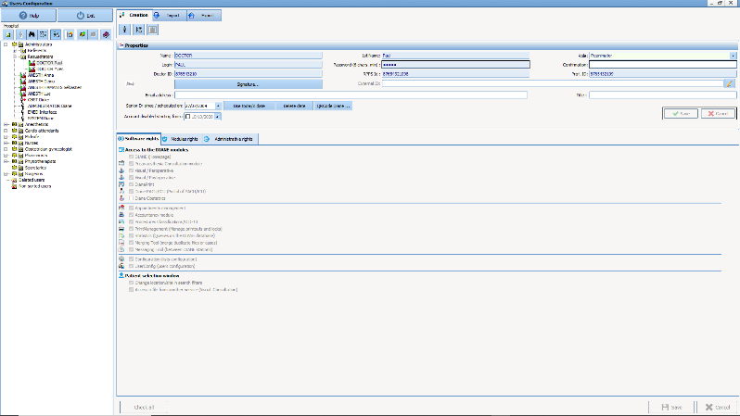
Permissions are managed directly in DIANE’s configuration tool. Permissions assigned to each user category can be changed. If an LDAP or SSO is implemented, users are placed in various categories but permissions continue to be managed in DIANE.

Printing of medical records
All data may be printed either on a central printer or at a point of care. Each field in DIANE features icons that serve as printing shortcuts. There are no printer requirements.
All data may be printed by users as needed simply by clicking the shortcut button.
The application features form letters that allow users to create preformatted notes and documents. The Word merge fields allow users to copy all the data in a record and add or change information directly in Word. The report and observation templates automatically retrieve patients’ administrative and physiological data.
The dataset for the medical unity summary (MUS) can also be printed to provide a easily readable overview on A4 size paper.

Archival
Diane’s architecture eliminates the need for archiving patients’ data. Instead, their entire records are stored in the database and can be retrieved in the event of a subsequent problem. This also allows any patient’s history to be accessed when analysing the unit’s activities. All data entered in DIANE are the property of the facility and may be archived on media if desired.
Electronic health records are archived in their entirety for the period prescribed by law.
Any archived record or set of archived records can be saved to removable storage media.
Partial archival in the form of text converted to PDF format may also be possible, in a format that allows records to be shared externally (record access permission)

Software updates
DIANE is developed and updated by Bow Medical’s team of 16 skilled engineers and technicians. Bow Medical has forged strong partnerships with:
- Lille teaching hospital,
- Hospices Civils de Lyon,
- Saint Louis Burn Centre,
- Marie Lannelongue Medical-Surgical Centre,
- Clinique Convert (Ramsay GdS),
- Antony Private Hospital (Ramsay GdS),
- Chambéry Hospital
And other healthcare facilities that contribute to monitoring and developments. Diane is fully owned by Bow Medical, which interacts daily with healthcare facilities. Updates are automatically installed whenever new regulations come into force.
DIANE comes standard with an updating system that distributes new versions electronically when DIANE is launched. There currently are two types of update: minor and major.
Minor updates are installed on the fly without having to stop any processes or shut down the database.
Major updates (which occur once every two years on average) entail converting the database. This means that the system will have to be taken offline for an average of four hours each time.

SETUP
Bow Medical provides a default environment tailored to the needs of facilities and anaesthesia and intensive care units. You start with a setup designed by Bow Medical’s product manager, training staff and nursing experts. This setup is a standardization of the work conducted at the many facilities where DIANE is already used (Lille teaching hospital, Lyon teaching hospital, Ramsay GdS clinics, Chambéry hospital, burn centre at Saint Louis hospital, Reims teaching hospital, Clinique Convert in Bourg-en-Bresse, Clinique du Millénaire in Montpellier, etc.).
In other words, you can launch your project with a complete environment that is tailored to the needs and requirements of anaesthesia and intensive care units.
After the first few training sessions, key users gain a broad understanding of the possibilities for scalability. Bow Medical’s trainer and nursing expert collaborate with key users up to the test phase and during the months following implementation. Throughout this period, key users gain all the knowledge they will need to be able to change the setup without any assistance. This support is one of Bow Medical’s strengths. Once the environment is implemented and validated, we continue to provide facilities and key users with information on features and make DIANE even better than it already is.
During all these phases, our project team is in constant contact with the product team in order to provide feedback and needs. As the project team is in direct contact with the product manager and the R&D director, decisions are taken extremely quickly.

INTERFACES WITH THE HIS
Bow Medical possesses extensive experience in connecting to third-party HIS solutions. Indeed, we have already created more than 270 different interface flows with more than 55 software companies for our DIANE software suite. Bow Medical is experienced in protocols used in the field of EHR (particularly HL7, HPRIM, PN13, CDA R2 and HPRIM XML) and monitors the work of the Hospital Information Systems Modernization Group (GMSIH). As a participant at the IHE-Europe Connectathon in Vienna, we validated all HL7 IHE PAM flows following successful tests with five companies of various nationalities. All this attests to our know-how in the field.
In addition to these standards, we also develop numerous interfaces and specific web services for third-party solutions such as Sillage, Crossway, HM, Dopasoins, DX Care and Emed, to name a few.
One of the main advantages of the Diane software suite is that the ICU and anaesthesia modules run on the same database. This means that the interfaces installed for one speciality will also be automatically installed for the other, limiting the number of interfaces installed in your facility.

Interfaces
We offer various interfaces to optimize the integration of DIANE with your HIS.
A diagram illustrating this optimal integration is provided below:

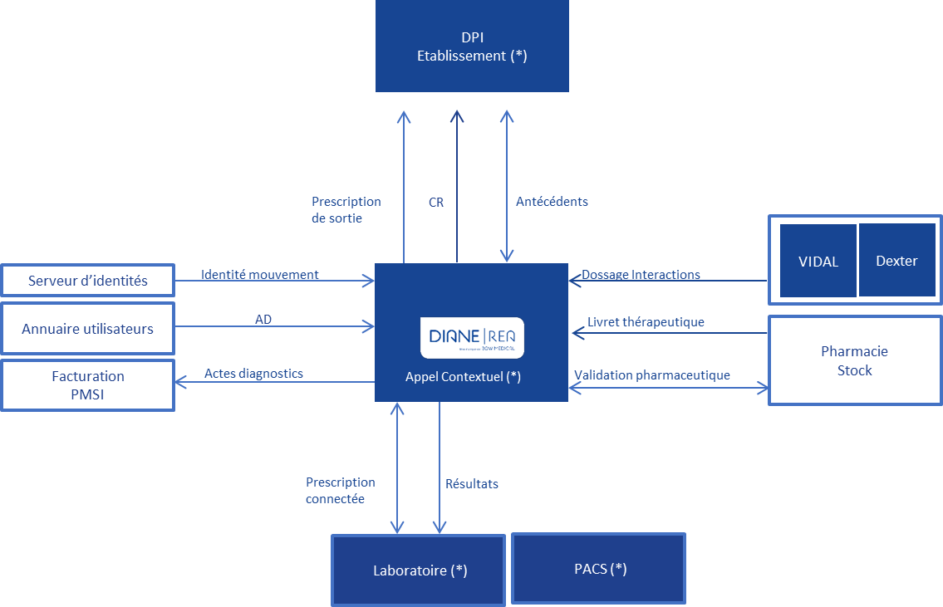
Pharmacist confirmation
Diagnostic procedures
Movement identity
Drug formulary
Dosage interactions
Results
Electronic medication order
Medical history
Report
Discharge medication order
Pharmacy
Inventory
Billing
PMSI
User directory
Identity server
PACS*
Laboratory*
Context-based information retrieval*
Facility EHR*

For all these flows, DIANE is compatible with a large number of formats:
Import |  | Export
Type | Format | Type | Format
Identities/Movements | - HL7 (file and TCP)  - HPRIM (file)  - EDIFACT  - Web Service  - Flat files | Procedures | - HPRIM XML  - Web Services  - DianeDataSet
User account | - LDAP  - Active Directory | ICD-10 | - HPRIM XML  - Web Services  - DianeDataSet
Medical history | - Proprietary XML  - Web Services  - DianeDataSet  - CDA R2 | Medical history | - Proprietary XML  - Web Services  - DianeDataSet  - CDA R2
Lab results | - HPRIM  - HL7 | Medication orders | - Web Services  - PN13
 |  | Documents | - HPRIM (document + HPRIM file)  - HL7 (document + HL7 file)  - HPRIM XML  - Web Services  - DianeDataSet
Contextual call | - POST method  - GET method  - Cookie  - Web Services  - Proprietary token | - Parameter passing  - File dropping  - API operation

Internal operation
Two types of interface are used during exchanges between the applications: server interfaces and client interfaces.

- Server interface: a 24/7 service that primarily processes incoming data flows in order to integrate them into the database. It can be installed on a Windows Server and requires a DIANE database client to connect to it. This service is configured by a DIANE module, which generates an .ini file that is directly available in the service directory.
This type of interface (identity, lab, etc.) makes it possible to manage the interfaces in detail via direct access to the configuration directory.
In addition, a log system monitors the interfaces and quickly identifies malfunctions.

Schematic of the server interfaces:
TCP connection
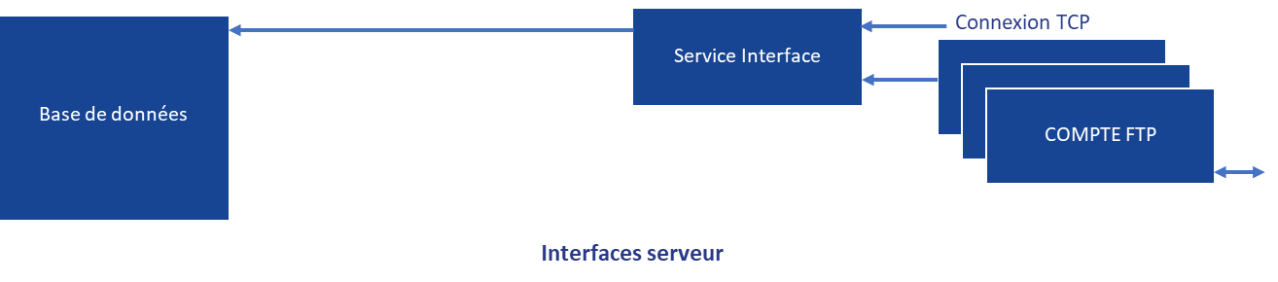
Server interfaces
FTP ACCOUNT
Interface service
Database

- Client interface: directly included in the Diane application on the client computer. It is configured by the DIANE configuration tool, allowing quick access to configurations from any location, with the corresponding permissions. These interfaces are primarily outgoing in order to export reports, send data to external procedure servers, export medication orders, etc.
A log and alert system makes it possible to quickly identify malfunctions.

Schematic of the client interfaces:
TCP connection
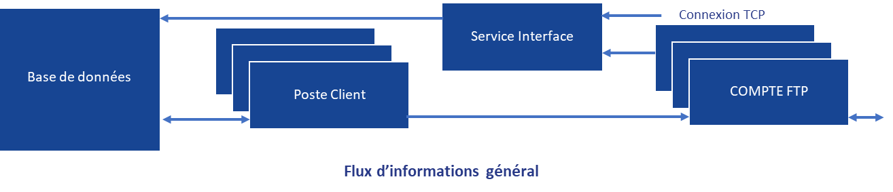
General information flows
FTP ACCOUNT
Interface service
Client computer
Database

ELECTRONIC ICU RECORDS
The DIANE software suite provides a functional and user-friendly environment that integrates a medication order engine and a CE-marked care plan as well as a complete patient record that is geared to all members of ICU staff (nurses, dieticians, physiotherapists, social workers) and retrieves biological, pharmaceutical and microbiological data. This mode of operation ensures that patients receive optimal and efficient treatment and a smooth transfer of information from one critic-care unit to another (ICU, CCU, CICU, NICU, etc.).

Functional overview

Visual identity, unit view and navigation
DIANE ICU shares the same visual identity as the DIANE Portal. The portal allows access to the DIANE modules and enables them to be launched independently of it.
DIANE ICU features a streamlined environment for simple and intuitive navigation.

The portal opposite allows users to quickly open all the DIANE modules, including ICU, anaesthesia, configuration, procedure codes and statistics.

The home menu of the ICU module, with the list of currently admitted patients, is shown below. This list provides an overview of the unit and the records of each patient in it. As it constantly evolves, it can be configured to display just the information you want your teams to see (scores, vital signs, etc.) so that your staff can see the status of their unit and very specific details about each patient.
The buttons give access to records and specific areas.

As DIANE ICU can be launched from any computer in a unit, users have access to an overview corresponding to the computer.
Users can then choose which units or beds to view.

Each patient record contains tabs that allow users to access all a patient’s information in a single click.
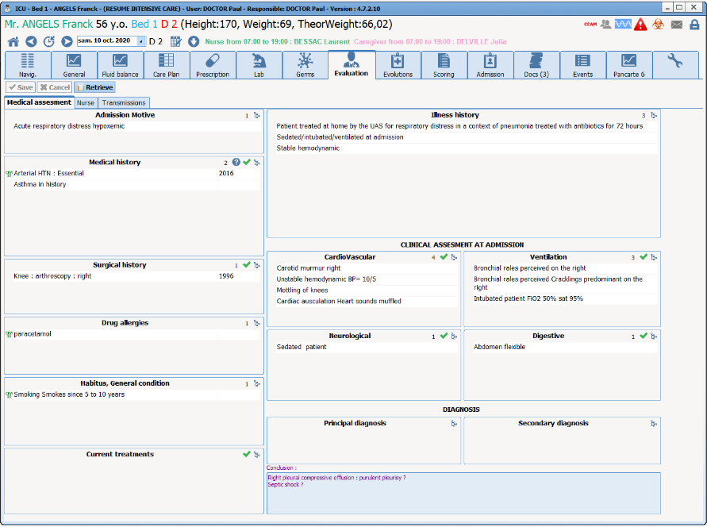

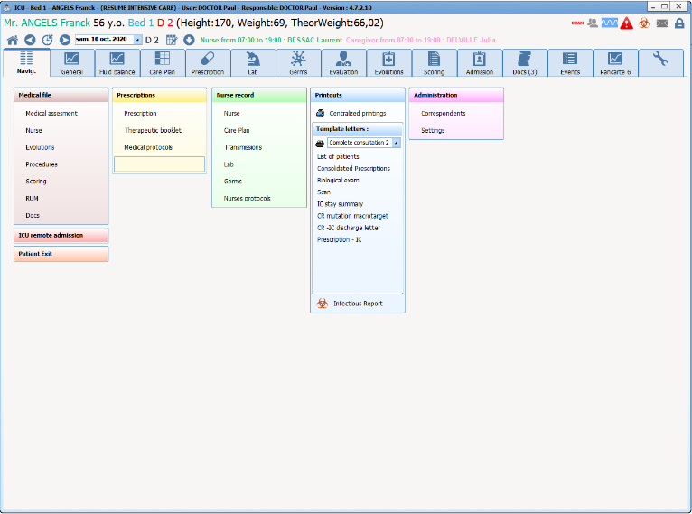

The Main tab (opposite) contains all the tabs and modules accessible from DIANE ICU.

Patient label/Patient identity verification
When a record is created for a patient, the movement identity interface collects their administrative data to create their DIANE record. If a patient is already registered in DIANE, this information is updated by entering the patient’s universal patient identifier (UPI). Multiple filters (last name, first name, date of birth, UPI, visit number, surgery date, consultation date, unit, etc.) can be combined when searching for patients. The results in the DIANE database and identity server are displayed in a single list.
If a patient’s identity is not found on the admissions server, a record can be created by entering a minimum of information.

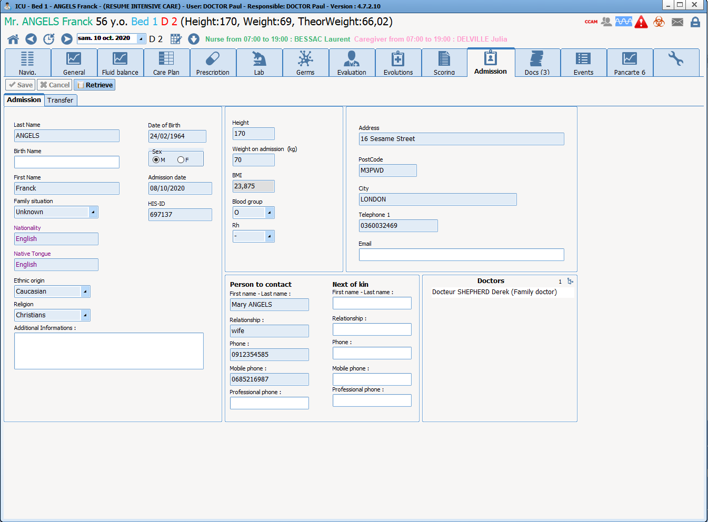
Once a record is created, the patient’s administrative data can be accessed in the dedicated tab and their identifying information are continuously displayed in the banner.

General view/Monitoring
Specific tabs allow medical and paramedical teams to view and complete patient records and thus provide a comprehensive view of a patient’s medical history.
From just one tab a doctor or RN arriving at the unit can therefore understand the circumstances that led to the patient’s admission and the ICU care provided. Other tabs include lists of examinations conducted during a patient’s hospitalization.
The General tab in the window below shows physiological data, laboratory data, the care plan implemented, scores, diuresis or other ‘losses’, major events such as complications, etc. It can be fully configured by key users.
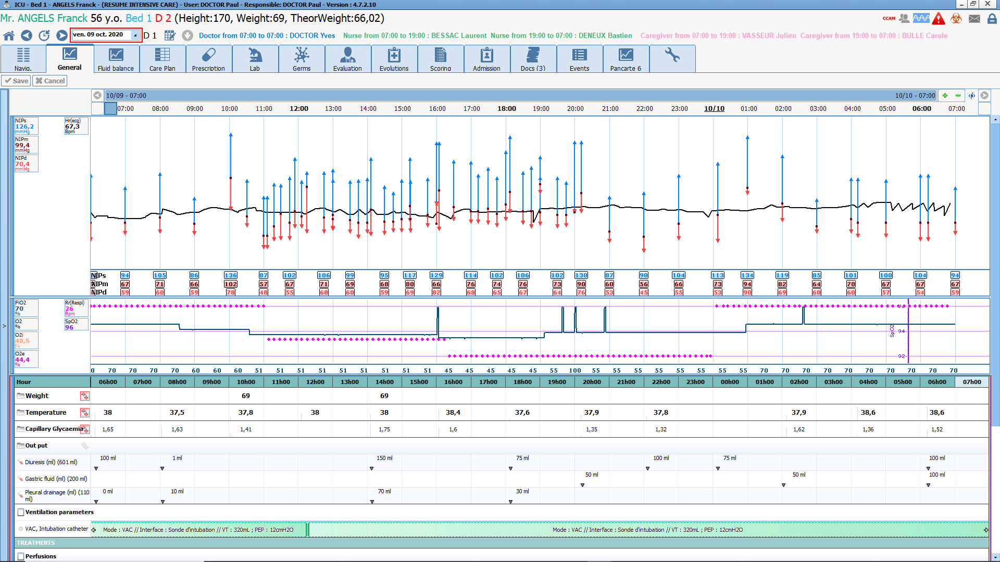

Fluid balance
The fluid balance window can be accessed at any time.
Intakes and output can be summarized as:
  - A list
  - Histograms showing, for each hour, intakes in blue and outputs in red
  - Cumulative chart of intakes and outputs over predefined period
The default time period is the current day, but this can be changed to a different day and to collapse or expand the viewing period.

Offline procedure/Offline mode
Thanks to its three-tier architecture, offline mode is one our solution’s strengths. When DIANE is launched, all configuration items and input catalogues (several tens of thousands of items) are updated in a local cache (encrypted files) and loaded into memory to make them instantly available. When a record is opened, its entire contents are therefore also loaded into the local cache.
This means that if a client computer loses its connection with the database DIANE will run in offline mode without losing any input tools or prior data entered in the record.
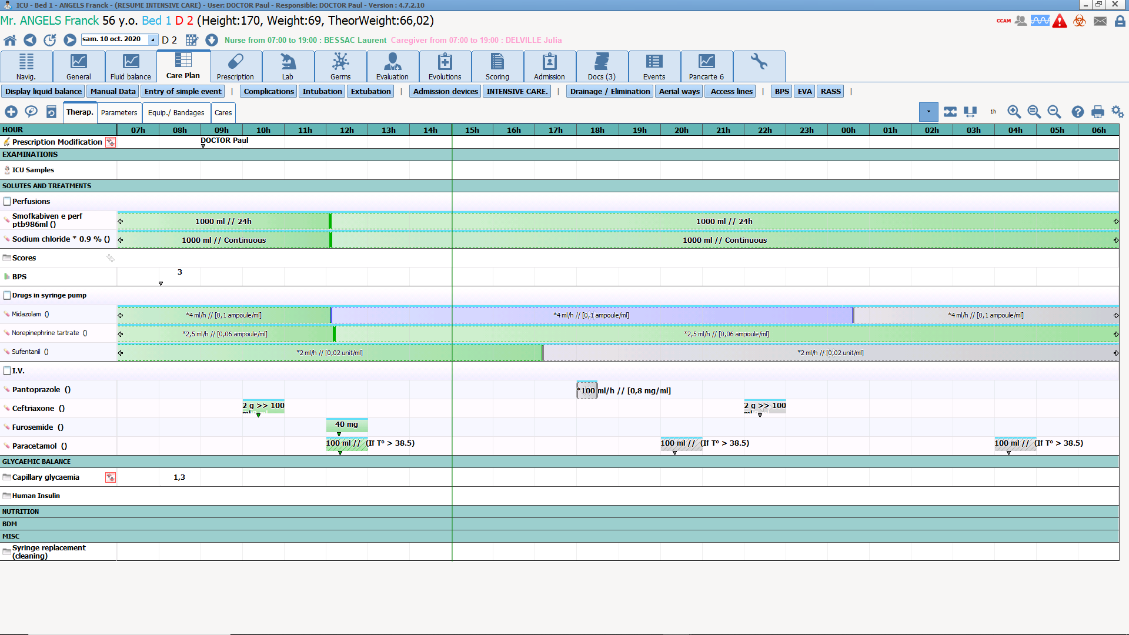
When the network connection is restored, all data are synchronised with the server.

Patient record
An environment is provided as standard and may be customized. The default environment is specifically designed for the types of data entry and structured display required by ICUs:
  - Arrival and discharge summary record
  - Medical observations/daily notes
  - Weekly summaries/stay summaries
  - Document integration
  - Per-device views (tab, table, chart) with displays that can be live-changed by users
  - Tool for searching all data in a record (lists, comments, etc.)
  - Etc.

Medical record

Reference lists, checkboxes, comments fields, drop-down menus and other form elements in the main tab allows users to quickly enter and display patient admission data (reason for admission, past medical history, treatment, clinical examinations, disease history, decision, etc.). The result is significant time savings, especially during change-of-shift reports.

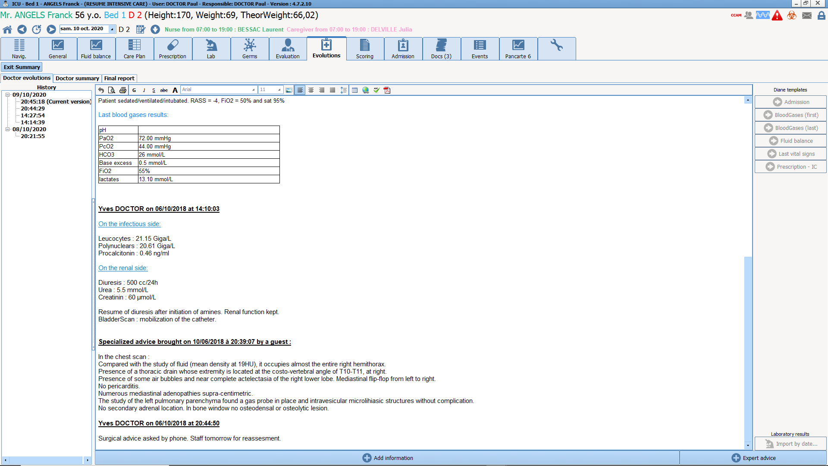 | Daily changes in a patient’s status are entered using a specific word-processing module that allows data from a patient’s record (medical history, laboratory, fluid balance, treatment, vital signs, etc.) to be automatically entered. Images and documents can be copied as well. The result is a detailed log that is accessible at all times.

Paramedical personnel/Nursing notes
A patient’s reason for admission and medical history are entered in the summary record, which allows staff to track all mandatory data. The tab also can be customized in many different ways. Documents are then automatically generated so that they can be saved, sent to the EHR or provided to patients’ families.
Checklists are available and appear automatically between each patient and at the start of each shift.

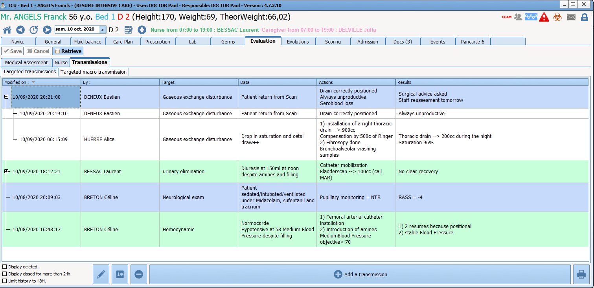 | Nursing notes are entered in a dedicated tab from a predefined and editable list. Three input fields (data, interventions, outcomes) are available for each type of nursing note. Nursing notes are listed chronologically by specificity. Subjects may be closed or flagged as important. This tab is designed to allow medical staff to see all nursing notes for a patient in a single window.

Configurable grids that allow redundant data population and sorting in chronological order are available for use by other health workers (dietitians, physiotherapists, psychologists, etc.).

Medication orders
DIANE ICU features a flexible, comprehensive and scalable medication order tool. The medication order module provides access to all ICU-related information (drugs, ventilator settings, dialysis, monitoring, procedures, nursing, nutrition, examinations, care, etc.).
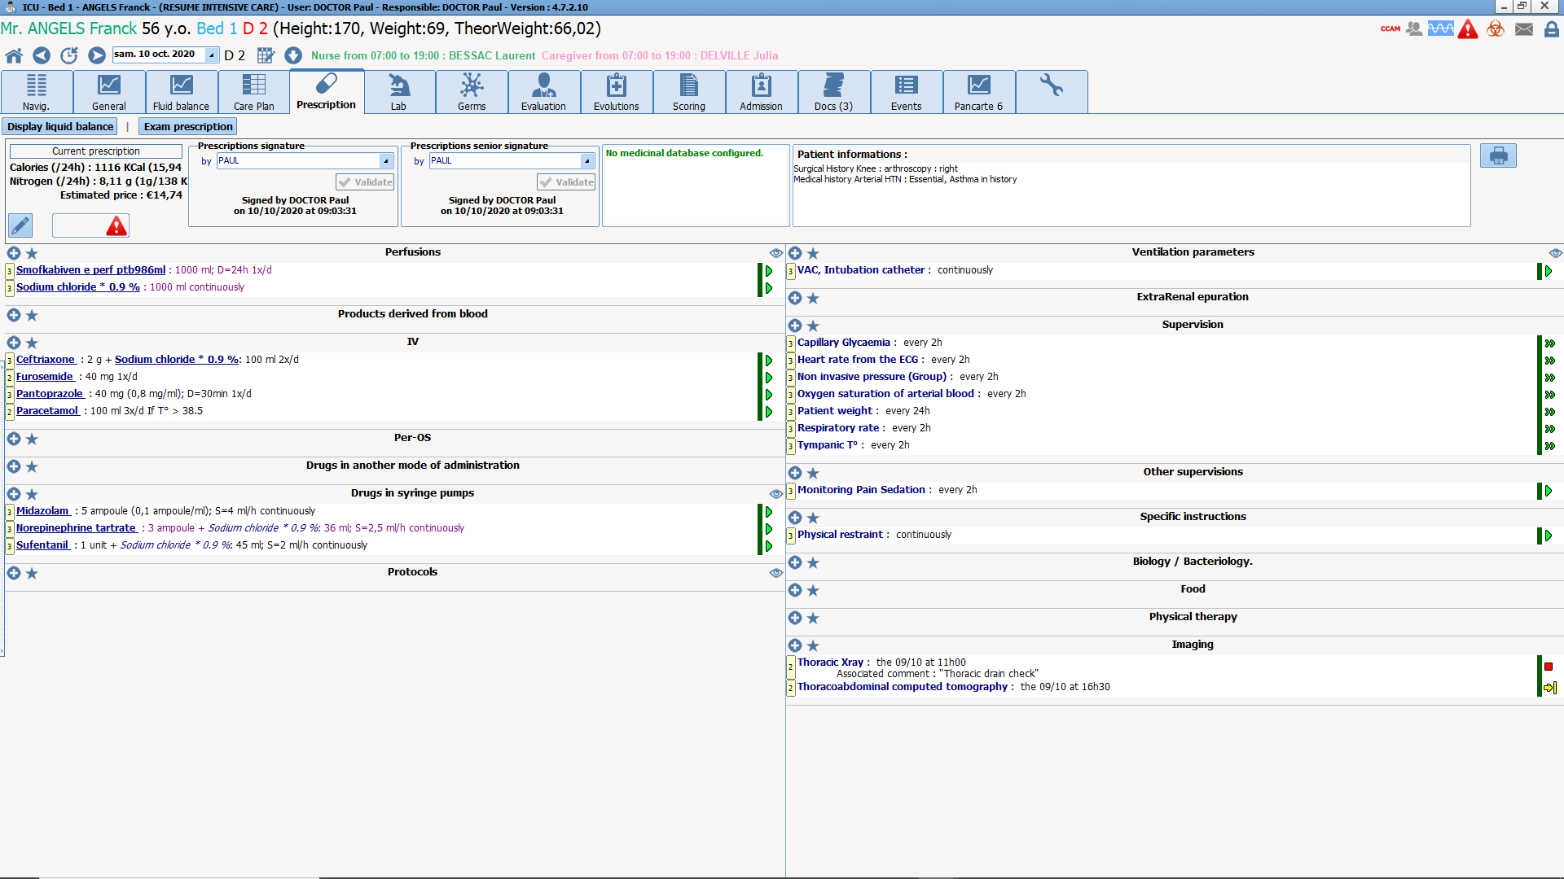
The current medication order is displayed in the medication order grid and provides doctors an overview with an efficient summary structure.

The eye icon in each zone displays the corresponding monitoring constants. For example, the ‘Drip’ heading allows doctors to see the latest laboratory results for a patient, the state of their renal function and their fluid balance.

Using the hospital’s drug formulary, doctors can prescribe dosages directly and have access to a complete catalogue of favourites and protocols that allow swift and secure entry. Protocols may be for routine or urgent needs (per os, drip, pain, insulin, etc.) or a type of admission (cardiac arrest, stroke, septic shock, etc.). Each protocol or medication order makes it possible to define:
- The schedule (morning, noon, evening, upon awakening, at bedtime, etc.; X times daily, X times every X hours, every other day, manually entered times, etc.);
- Dosages that can vary over the course of a day (e.g. 5mg in the morning then 10mg in the evening);
- Dosages of injectable drugs along with their durations, concentrations and flow rates;
- Infusions or syringes containing multiple active ingredients and a solution. At entry, drug dosages can be set to zero for several days and then set back to their original values in a single click.
- Conditional medication orders with target concentrations. Flow rates entered by nursing staff in the views are suggested to doctors when new medication orders are written.
- DIANE integrates the entire Meynaar protocol.
- …
DIANE is certified as an e-Prescription software solution by the Vidal and BCB databases and the entire medication order process is secured by a drug database for drug and allergic interactions. DIANE meets multiple patient care criteria and medication orders must be confirmed at least once a day. This module is flexible and suited to ICU settings, integrates ICU protocols, meets standards on antibiotics, uses INN terminology, and allows the entry of drugs not contained in the formulary.

When medication orders are entered, a whole set of calculations is automatically performed based on the order choices and patient data (sex, weight, height, etc.). Doctors can choose the units used in medication orders (mg/h, mL/h, µg/kg/min, etc.) in a single click.

When data are entered, various flow rates and amounts are calculated in real time to help in the preparation process. Charts for the scheduling and contents of syringes and drip bags are generated in real time.
Typical dosages and protocols are defined and configured in advance. During the entry of data, protocols are selected by doctors and can be quickly edited according to the patient to issue medication orders swiftly and securely.
All changes made to medication orders are tracked by signature or doctor confirmation. DIANE is fully suited to the frequency of changes that occur in ICUs and a new layer is added to the log each time a change is made. This log accessible by all doctors at all times.
In the case of urgent administration, there are two solutions: medication orders either are made and confirmed in DIANE after the fact or given verbally. In the latter case, the nurse enters the administration data directly in the care plan along with the name of the prescribing doctor and an alert is automatically sent to the doctor so that they can confirm it in the medication order. Nurses have access only to a predetermined administration list.

Pharmacist confirmation
Pharmacists access the medication order module to:
- Confirm medication orders row by row;
- Confirm medication orders with a single click;
- Add alerts or comments to individual rows;
- Add a comment to entire medication orders.
Doctors then see this information in the medication order along with an alert on the list of currently admitted patients.

Drugs not included in the all-inclusive rate/Antibiotics
When drugs not included in a hospital’s all-inclusive rate are prescribed, DIANE automatically opens a window so that doctors can enter details about the medication order.

Checks are also requested when antibiotics are prescribed and at initiation, evaluation and re-evaluation.

Non-medication orders
There are also many possibilities for non-medication orders.
- Nursing and monitoring procedures linked to medical-device data;
- Lab tests and imaging examinations are prescribed in DIANE but can also be prescribed in third-party solutions via context-based information retrieval. Networked medication orders can also be made;
- A specific, structured grid is used to precisely prescribe ventilatory parameters with various dosages and specific times and durations;
- Dialysis and haemofiltration sessions;
- …
In addition, the configuration tool can be used to customize the medication order tool in order to define procedures and specific grids for your protocols.

Care plan
The care plan is automatically built as medication orders are given. Each time a change is made, an alert appears on the networked computers and home page in order to inform paramedical teams.
A colour-coded table with icons enables staff to quickly identify medication orders and prepare the necessary administrations.
Nurses then record these administrations using simple tools designed to log actual events.
Completed interventions are recorded in a single click. Staff can also:
- Specify actual intervention times
- Add comments
- Indicate when a drug was not administered and why
- Add further information for conditional medication orders
- Track changes in flow rate

If DIANE is connected to infusion devices, flow rates and concentrations are automatically logged in real time. If a difference with a medication order is detected, alerts are displayed for acknowledgment by users.

Devices/dressings/anatomical diagram
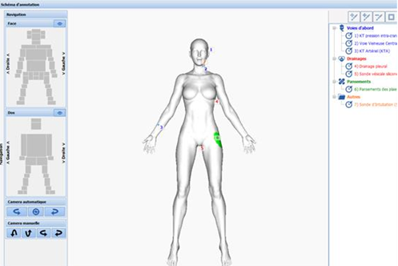
DIANE features a 3D anatomical diagram of the human body for tracking invasive devices and dressings. Information is added simply by clicking on the anatomical diagram, which is divided into zones so that entry suggestions can be customized for each zone.
The day-to-day progress of patients is tracked by moving the time cursor.
Care protocols are associated with each item in order to automatically send data contained in monitoring charts to the care plan. The fields in these charts can be parameterized and losses can be in mL.
Pictures taken with a smartphone or tablet can also be added.

Views
The General view shows the key data in a record and provides a summary of a patient’s status.
The other views allow staff to monitor devices attached to a patient and display a patient’s entire stay or zero in on a particular time. Its user-friendliness provides a clear and efficient picture of patient records.
The default period is one day, but the time scale can be changed in a flash. The data in these views can be displayed in tabular format (icon, numerical format, text) or as charts. Basic views (haemodynamic, dialysis, respiratory, infection, neurological, invasive devices, lab, etc.) are provided by default, but it is possible to edit them and add others via the configuration tool. A wide array of chart options can be used to customize these views to your needs.
Data (procedures, losses, scores, etc.) can quickly and intuitively added to tables with a single click.
Examples of the General tab and haemodynamic and respiratory monitoring views are provided below.

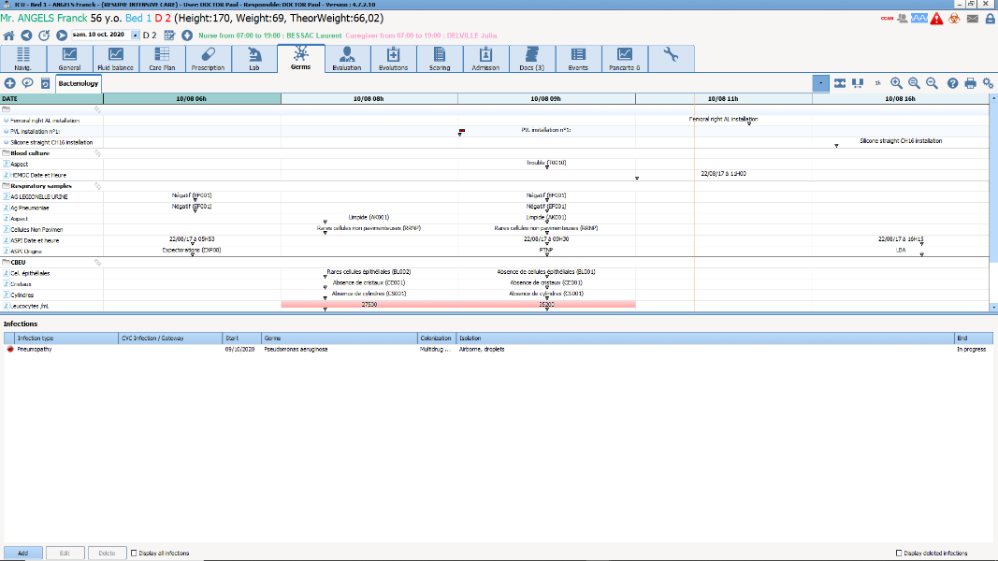
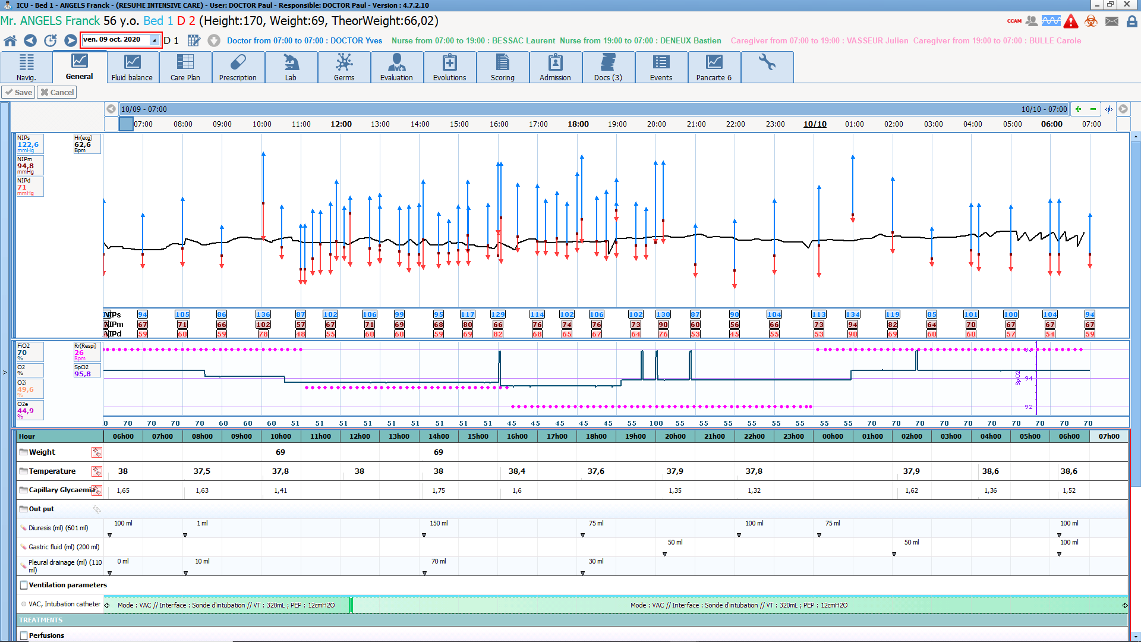

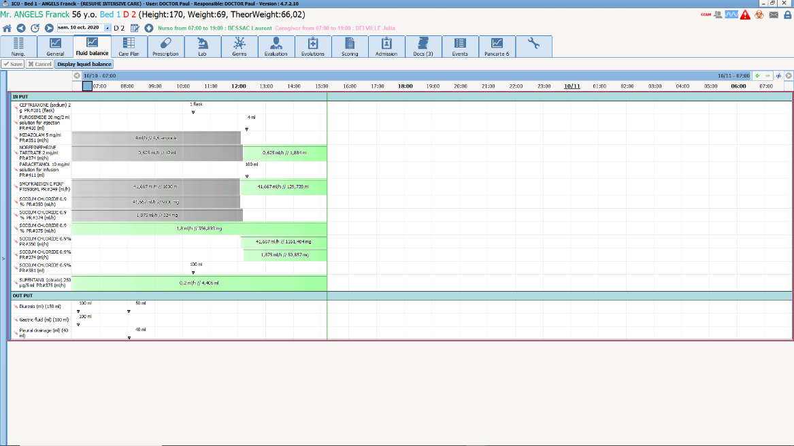

The Invasive Device tab allows staff to quickly view devices inserted in patients, the associated timers and the necessary interventions (replacement, monitoring, dressing, etc.). Invasive devices are tracked in a comment box using a handheld scanner. They can also be entered wholesale in a single field to make searching easier.

Connection with medical devices
Medical devices connected to DIANE automatically send all a patient’s vital signs to their specific record, where they are logged and translated into real-time views. Connections between DIANE and devices are maintained without interruption and no human intervention is required when a patient is admitted. Devices and connections may be changed at any time.
All data are recorded in digital format. DIANE then processes these data and displays them in the appropriate manner (tables, curves, scatter plots, area charts, arrow charts, etc.) in the various views.
Nurses can confirm these data according to the corresponding medication order or freely. Although regulations prohibit the changing of automatically acquired data, it is possible to indicate artefacts.
Medical alarms are also recorded in patient records and alerts appear if a connection is lost.
Staff can also manually enter data not automatically retrieved by DIANE, either in real time or after the fact.

Attached to our reply is the list of devices that can be connected to DIANE. Generally speaking, DIANE can be connected to the following devices:
- Monitors
- Ventilators
- Syringe pumps
- Infusion devices
- Dialysis machines
- Haemodynamic monitoring systems (PiCCO, Root, Vigiléo, EV1000, etc.)
- Transoesophageal Doppler
- …
All data collected by these devices (including measurements and settings, particularly regarding ventilators and dialysis machines) are recorded in DIANE in real time and without any filters. As a result, users can display any new data at any time in the views. They will see all the values recorded from the start of a patient’s stay.

Laboratory
Lab results are logged in DIANE automatically and in a structured manner. This interface is available in HL7 or HPRIM Santé format.
These data are then presented as tables or charts.
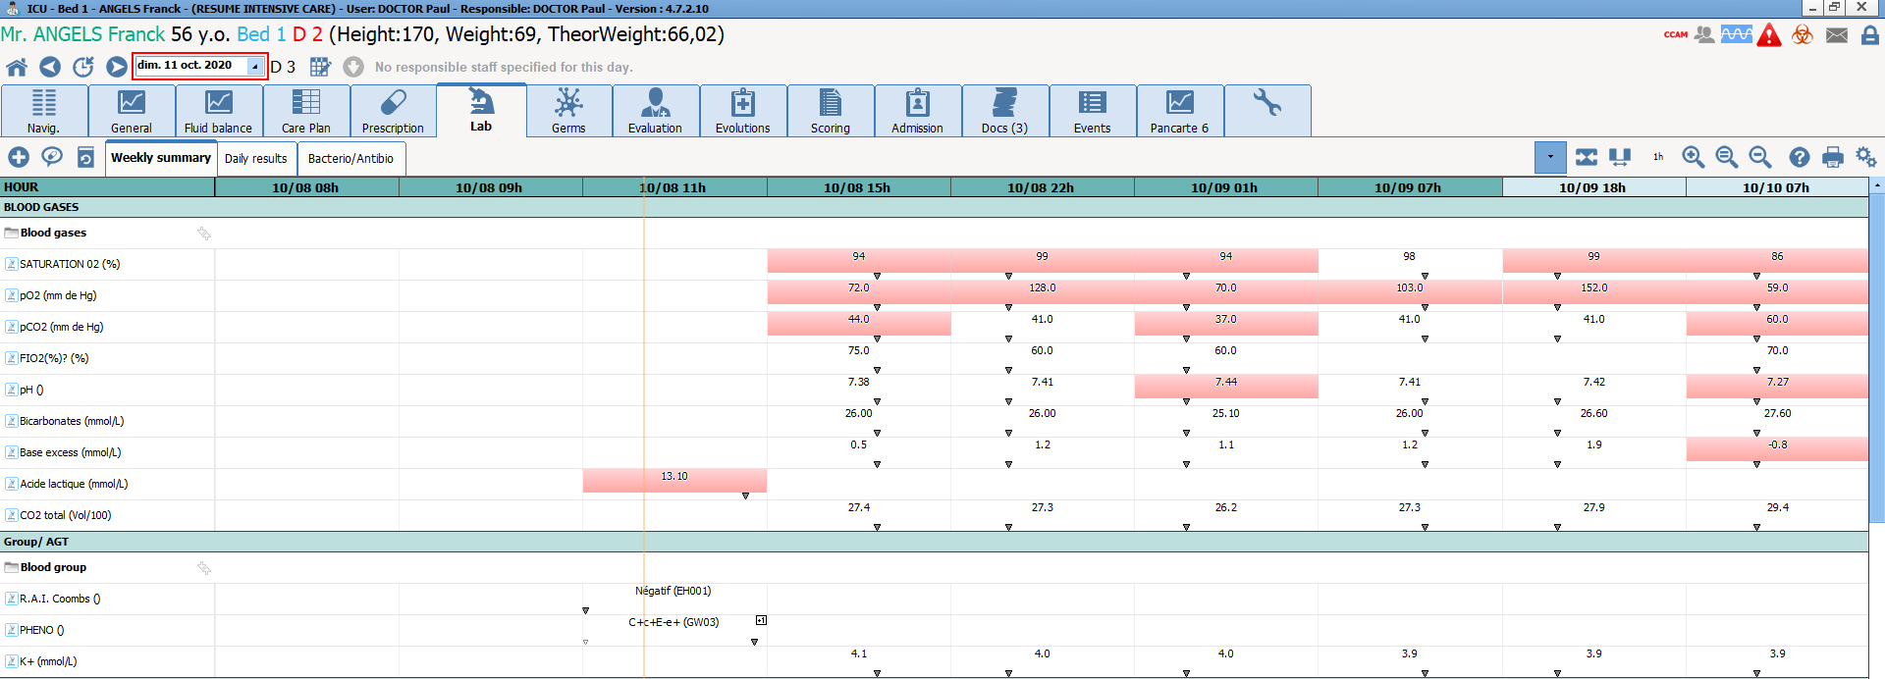

GUI and viewing format
The views are used to cross-reference all the data in a patient record. The customization possibilities allow each item of data to be adjusted to the needs of your unit. Data can be displayed in tabular format or charts in multiple tabs. Tables and charts can be displayed in the same tab in order to cross-reference data. A wide array of chart options (colour, type, etc.) can be used to customize the data being displayed. The time scale can be changed in all views so that users can either display a patient’s entire record or zero in on a particular period.
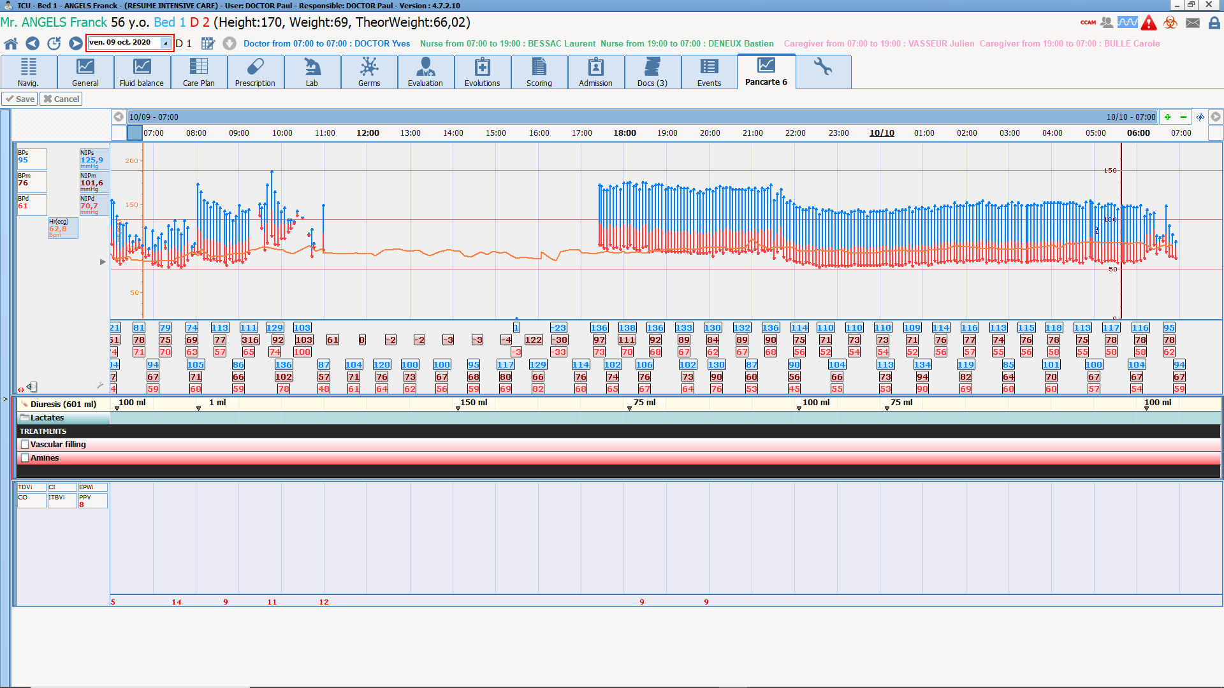

Marker procedures/PMSI
SAPS II scores are calculated automatically based on data retrieved automatically and information entered by users. However, doctors retain control over all score components, be they information not yet entered in DIANE or information contained in automatically populated fields.
ICD-10 diagnosis codes, procedures and marker procedures are automatically detected by DIANE from medication orders, views and data collected from medical devices. Hospital services are therefore billed in full and information is centralized. Users retain control over this pane in order to manually delete or add procedures and diagnoses.
All this data can be exported to your facility’s procedure server.

Report
DIANE comes with customizable reports that can contain all the data in a patient’s record so that prescriptions (documents exported to your facility’s patient record) can be generated and provided to patients’ families, the patients themselves and to their general practitioners.
Two formats are possible:
- A text file containing all the information in DIANE via a merge field and tag system. This document can then be edited with Word, OpenOffice or an editor integrated in DIANE.
- A PDF containing the various views and medication orders. This PDF is generated directly via a tool integrated in DIANE.
The information in all the tabs can be printed independently.

Closing of patient records
Two main solutions are possible when closing a patient record:
- If the patient is discharged from hospital, their record is closed and the corresponding reports are exported to the EHR system.
- If the patient is transferred to another unit in the hospital where DIANE is used (CCU, ICU, OS, maternity unit, etc.), their record is closed and then reopened in the receiving unit. The patient’s entire record is accessible, ensuring a totally smooth transfer of information between units.
In cases where a single database is used by several facilities, patient records are shared among all units.

Dashboard
Units have access to a dashboard that shows all the information and indicators needed for day-to-day management. Although this dashboard comes with a default setup, you can define the criteria and filters you wish to use.
The dashboard displays indicators (scores, levels, numerical values, etc.) or patient lists that can be anonymized.

ELECTRONIC ANAESTHESIA RECORD
The DIANE Anaesthesia module provides a functional and ergonomic environment for following up patients undergoing anaesthesia procedures throughout the various phases (appointment, first preoperative assessment, second preoperative assessment, induction, intraoperative, RR) and integrates a complete patient record for sharing information amongst hospital staff (anaesthetists, nurse anaesthetists, nurses, secretaries, managers, etc.)

Visual identity and navigation

Visual identity, unit view and navigation
DIANE ICU shares the same visual identity as the DIANE Portal. The portal allows access to the DIANE modules and enables them to be launched independently of it.
DIANE Anaesthesia features a streamlined environment for simple and intuitive navigation.

The portal opposite allows users to quickly open all the DIANE modules, including consultation, intraoperative, postoperative, configuration, procedure codes and statistics.

Patient identity verification
A patient’s identifying information is displayed in every DIANE window and module so that open records can be identified quickly and at any moment.

When a record is created for a patient, the movement identity interface collects their administrative data to create their record. If a patient is already registered in DIANE, this information is updated by entering the patient’s UPI. Multiple filters (last name, first name, date of birth, UPI, visit number, surgery date, consultation date, unit, etc.) can be combined when searching for patients. The results in the DIANE database and identity server are displayed in a single list.
An interface with Orbis suite management is expected to also create surgical procedures in DIANE and thus complete information such as the type of scheduled surgery, its date and the surgeon.
If a patient’s record or identifying information is not found on the server, a record can be created by entering a minimum of information. This record will subsequently be merged with the relevant identifying by means of an automatic proposal.
The merge tool makes it possible to search for and correct duplicate entries between DIANE patients or a DIANE patient and identifying information from the HIS.
Our query system and worklists generate patient lists that can be configured using various multiple criteria (biology results, record validation, surgery date, past medical history, etc.). These lists can contain all the information in a patient record in order to offer solutions to help you to optimise the organization of your unit and each patient’s journey.

Preoperative assessment
The consultation module was developed with anaesthetists and the Evalab usability engineering laboratory. Its default configuration follows the logical steps of a consultation. All this with simple input tools (checkboxes, comments, predictive text, drop-down menu, scores, etc.) to keep the connection and discussions with patients.
The default configuration provides an environment tailored to preoperative assessment. This means that the software is delivered ready to go with the relevant information (schedule, past medical history, examinations, biology, decision, etc.) that needs to be entered. The configuration tool allows you to adjust the usability and organization of the fields and their content.
The drop-down menus in the form of a tree structure enable information to be entered quickly all whilst having access to a complete list linked to the ICD-10.
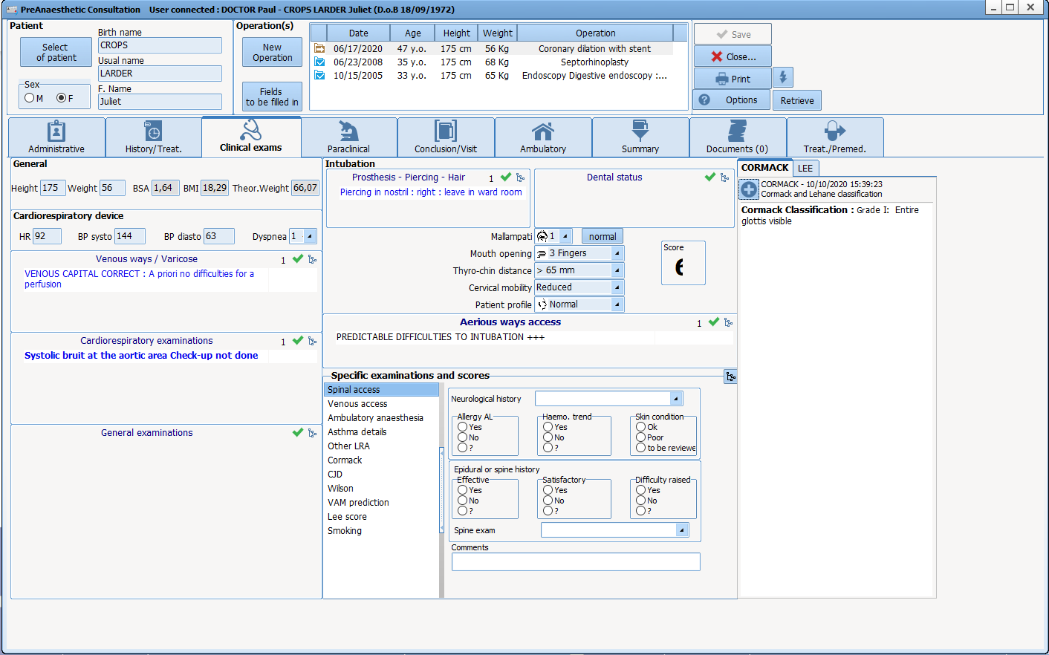
The main assessment fields enable information to be entered via context menus. Users are guided either by the menu or by predictive text. Free-entry fields are also available for less common conditions or conditions absent from the menus. A date can be indicated for each type of information entered.
Intubation criteria or other limited-choice information are provided in drop-down menus or checkboxes for efficient entry and viewing.
Specific grids for automatically calculating scores are provided. These scores can retrieve information entered during the POA and be used in the calculation.
An expert module makes it possible to set up automatic items (past medical history, treatments, premedications, decision, etc.) based on certain entries.
Information about a patient’s personal treatment is entered in a structured manner and allows conversions, stops and premedications to be set up according to your protocols.
Important and critical information is available by default (decision, child welfare, Mallampati, mouth opening, etc.) to allow protocols and data-entry rules to be put in place. This feature meets French (IPAQSS) criteria (indicators on improving the safety and quality of care) for records that are complete and which comply with proper patient management.
All information entered in a POA record can be highlighted by doctors to allow them to see all important information in one place and at a single glance.
Once all the necessary information is entered in a POA record, reports and prescriptions are generated and sent to the EHR system or handed directly to the patient.

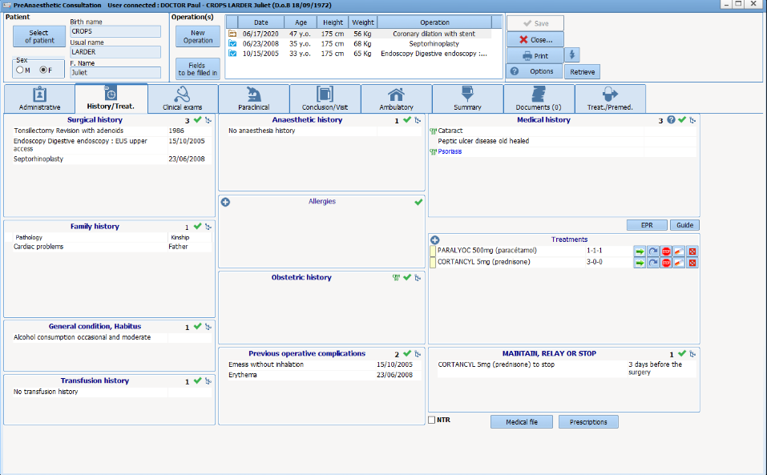
Previous consultations
When a patient is already registered in DIANE because of a previous visit, their data is automatically retrieved from the database and may be edited or deleted in a single click.
Their previous visit can be viewed by clicking in the list of previous surgeries without having to toggle from one window or screen to another.

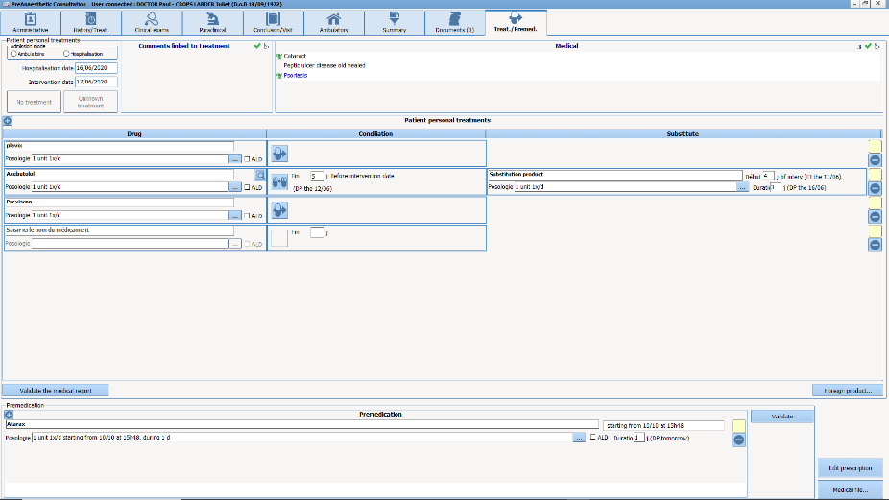
Medication orders
Treatments are routinely entered in a structured and secure manner via a drug database with a dosage field suited to POAs.
Premedications, conversions, continuations and stops are managed by doctors with suggestions made automatically according to a patient’s treatment and your protocols. Prescriptions are then generated automatically.
DIANE is certified as an e-Prescription software solution by the Vidal and BCB databases.

Lab tests
First of all, prescriptions and requests for specialist consultations are managed in DIANE via a dedicated field. Prescriptions are then generated. A set of templates is available and each template contains the exact consultation data needed to ensure proper patient management.
DIANE is compatible with HL7 and HPRIM Santé formats for retrieving data from medical laboratories. This allows results to be managed and displayed in detail directly in consultation records in order to confirm or invalidate records, identify worklists or build patient views.
Regarding electronic medication orders, our meeting with the Hexalis team enabled us to identify the necessary developments to be made. We are working towards a solution that will enable examinations to be entered in DIANE and exported to Hexalis. In return, we will have a code in order to print labels. Implementing this interface will require the collaboration of both Agfa and the facility’s project team in order to clearly define the specs and confirm its launch. However, it will be important to look into where the sample will be confirmed.

Anaesthetist’s decision
The anaesthetist’s decision, the proposed protocol, the information given to the patient and other elements are by default entered in the same tab of the consultation record and via lists. Protocols are specified and, with the assistance of the Expert module, suggestions are configured depending on the scheduled surgery.
During a POA, doctors can flag data as important and send them to a specific field so that they are visible in one location.
All data entered during a POA are populated to the report sent to the patient record and archived in DIANE. All changes are logged and timestamped and the report is exported again.

Previous medical examination reports/prescriptions
Documents brought in by patients can be scanned during consultations by means of a multifunction printer and added directly into their DIANE record.
Scanned documents are then sorted by name, date, type, etc., and can be exported to your facility’s EHR system.

Information given to patients
The anaesthesia record contains a field for entering all the information given to patients (risks of surgery, types of anaesthesia, Jehovah’s Witness, risks related to hospitalization types, etc.).
This information can then be printed out and given to patients. The document can include any other type of information provided during the POA, such as the type of scheduled surgery, the anaesthesia protocol, instructions, premedications.

Preoperative assessment/mobility
A pane for the second preoperative assessment is provided in the POA or intraoperative module. The list of patients will be available depending on the surgeries scheduled for the current or following day. Upon opening a record, doctors can access it in full and complete the second preoperative assessment.
As for mobility, DIANE is installed on tablet PCs that allow for bedside consultation. DIANE is also available on tools such as Citrix, AppliDis and TSE so that it can be accessed from any computer in your facility.
At the end of the second preoperative assessment, the POA report is generated and exported again to your facility’s EHR system (provided there is an interface).

Patient list
A quick-entry tool allows a list of patients to be filtered according to user-defined criteria. From this list, users can:
- Enter information quickly (perform the second preoperative assessment)
- Display patient data
- Open consultation records
This tool is used in particular to perform second preoperative assessments, have a list of patients during MDT meetings and identify records that have not yet been confirmed.

Intraoperative

Safety checklist/important items
Surgeries are selected from the list of surgeries scheduled for the current day. The patient search tool is also accessible.
Safety checklists are suggested at the start of each day and inter-patient checklists are suggested between each patient. An example of each of these documents is provided by default but you can of course customize them as needed. Their entry and confirmation by doctors can be made mandatory.
In emergencies, patient records can be opened first (via a bar code) and checklists can be completed later.
Important items and IPAQSS criteria (staff present in rooms, in-charge staff, safety checklists, complications, etc.) are configured to be suggested automatically using quick entry. In addition, checklists containing uncompleted fields may be blocked.

Anaesthesia record contents
Firstly, all information entered in DIANE is timestamped along with the ID of the staff member who entered it. The names of present staff are entered via the monitoring window either via quick entry or auto entry depending on the schedule.
All the steps in surgery are documented using lists and libraries that are provided as standard but which may be edited by key users to customize the environment to reflect routine and new practices.
The various tools allow all information in a record to be entered quickly and after the fact:
- Staff present;
- Surgery start and end;
- Position;
- Procedures;
- Monitoring;
- Products (quantities, times, flow rates, with automatic dose accumulation);
- Solutions;
- Losses;
- Consumables;
- Scores;
- Etc.
A menu, the search tool and the comment box are accessible at any time to enter specific items.
All information entered can be subsequently be edited, deleted and shifted over time (drag and drop). Comments may be added in a free-entry field.
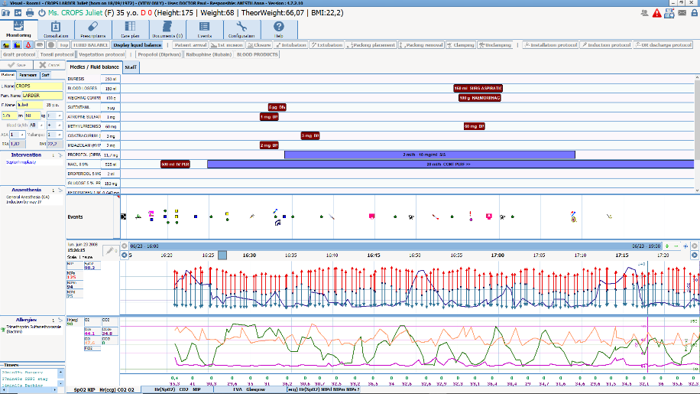
An advanced engine makes it possible to add timers and alerts in case of a failure of procedure.
All this information is used to automatically calculate the fluid balance in real time.
In special cases where a patient is prepared in the pre-op room (local and regional anaesthesia and induction), DIANE can indicate that surgery started there or in recovery before transferring their record to the operating theatre.
The configuration of the quick-access buttons and protocols can be the same for the entire OS or be made specific to each room and surgical speciality.

Display
The display of the intra/post-op record with vital signs and the quick-access buttons is completely scalable and configurable. Various environments are possible depending on:
- Hospitals belonging to the same hospital group
- The OS
- The OT
- The induction room
- The RR
- …

Drug administration
DIANE features specific tools to easily and quickly track drugs administered to patients. The entry menus are designed for the various practices related to anaesthesia:
- Entry of drugs integrated in protocols;
- Real-time data entry;
- Real-time totalling of intakes and outputs;
- Bolus dosages;
- Flow-rate dosages (with stops in real time or after the fact);
- Volumetric dosages;
- Appropriate units (gamma, mL/h, mg/mL, µg/kg/min, mL, mg, g, etc.);
- Halogenated gases;
- Blood products;
- Losses (diuresis, drains, bleeding, etc.);
If DIANE is connected to infusion devices, all the information logged by them is collected automatically and in real time (product, concentration, flow rate, quantity).
All this data is plotted in a chart showing the timestamps of each vital sign and event.

Protocols
Scalable protocols are provided by default to allow quick entry after the fact. These protocols make it possible to enter all events, drugs, scores, losses, etc. for each step (placement, induction, recovery, etc.) or for an entire surgical procedure in just a few clicks. Each protocol line has a default time offset that can be changed at the time of entry.
Its ease of use, straightforward configuration and flexibility make this module one of DIANE’s strong points for intraoperative and postoperative periods.

Postoperative medication orders
DIANE features its own postoperative medication order module (in the process of obtaining e-Prescription software certification) that has all the tools needed to make postoperative medication orders and create care plans. All medication orders can be exported in PN13 format in order to reconstruct care plans in your facility’s EHR system.
Postoperative medication orders can also be made directly in your facility’s dedicated or off-the-shelf solution using context-based information retrieval buttons that are quick to use and can be configured by your facility and key users without any outside assistance.

Discharge from the OS or OT
When a patient is taken out of the OT or OS, any important items that have not yet been entered are flagged. There also are alerts for protocol errors, which can be corrected if needed.
Users can then indicate where the patient is being taken to in order to build RR or ICU waiting lists. The patient’s record can also be closed directly upon leaving the OT or OS.

Connection with medical devices
Medical devices connected to DIANE automatically send all a patient’s vital signs to their specific record, where they are logged and translated into real-time curves. Connections between DIANE and panel PCs are maintained without interruption. No human intervention therefore is required when a patient arrives for surgery. Devices and connections may be changed at any time during surgery.
Thanks to our drivers (see list provided as an attachment), DIANE can connect to the majority of surgical equipment and devices, including monitors, ventilators, infusion devices and blood salvage devices.
Bow Medical owns its drivers and is constantly updating them and keeping a constant watch in order to develop new ones for new medical devices.
Data that are retrieved automatically cannot be deleted or edited. If necessary, information can be flagged as incorrect by entering an artefact.

Display and viewing
All the information in a patient record is displayed in a single window. Drugs, procedures and vital signs are displayed in three panes in the same tab, making it possible to visually cross-reference and correlate all the information. Charts can be customized (displayed data, colours, chart type, table format, scale, etc.) to suit DIANE to your needs and to each patient. The time scale adjusts itself automatically based on the duration of surgery. However, users can zoom in on specific areas or have an overall view.
When a record is open during patient and surgery prep, important information recorded during the consultation appears on the main tab and the entire consultation can be accessed in one click.

Fluid balance
The fluid balance window can be accessed at any time.
Intakes and output can be summarized as:
  - List;
  - Histograms showing, for each hour, intakes in blue and outputs in red;
  - Cumulative chart of intakes and outputs over predefined period.
The default time period is the current day, but this can be changed to collapse or expand the viewing period.

Recovery
Although identical to the intraoperative module, the RR module features a graphical environment and shortcuts specific to recovery rooms. The data-entry tools are the same as those in the intraoperative module and the protocols are of course specific to recovery rooms.
Connection with medical devices is also set up with monitors, ventilators and infusion devices.
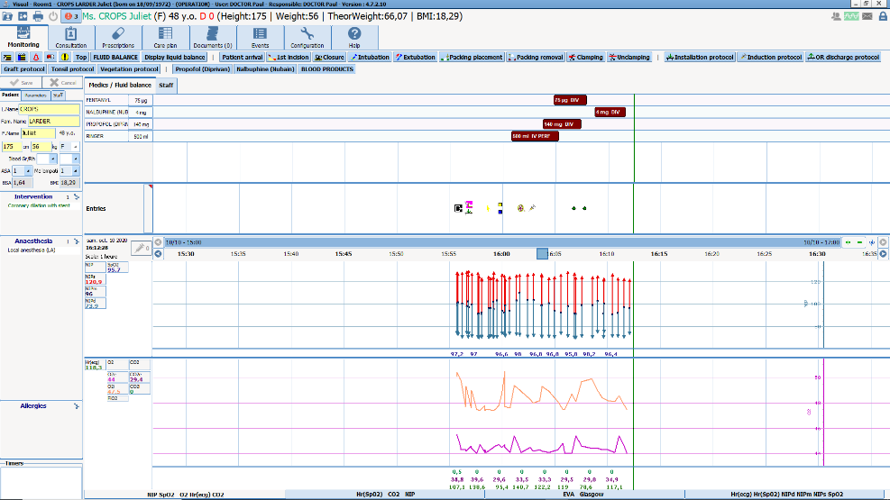
A protocol and RR score are available for discharging patients. The doctor performing the surgery must also sing the discharge form.
Records for each patient in the RR can be accessed from multiple computers in the OS (see operation of primary/secondary computers further on).
A DIANE medication orders module is accessible for RR and ICU staff. When a patient is transferred back to a unit, context-based information retrieval towards the patient’s record may be set up.
Reports are generated and sent to patient records. These reports are configurable and contain all the date entered and collected in the OS/OT.
Furthermore, when a patient record is opened, both recovery and induction (using the appropriate setup) may be started if local and regional anaesthesia are administered in recovery.

Discharge from the RR
Doctors may, at any time, confirm patients’ discharge forms and indicate various criteria (score, duration, time, etc.). They must then sign them using their login and password. They may also sign them in the OS/OT at the end of surgery.

Report
An operative report is generated and may be exported automatically to your facility’s EHR system. This report is scalable (tables, charts, score, etc.) and documents all the data logged during surgery.
Whenever necessary or if a procedure is initiated, reports providing more detailed views of events, drugs and vital signs along with the associated decisions and time matches may be generated.

Closing of patient records
Although patient records are usually closed in the recovery room, they can also be closed in the operating theatre if a patient is not transferred to recovery. Once a patient’s record is closed, the patient may be brought back to surgery within a period defined by your facility (24 hours by default).
When a patient is taken back to the unit, the postoperative medication order may be created in the EHR using context-based information retrieval. If your facility uses both DIANE Anaesthesia and DIANE ICU and a patient is to be transferred to recovery, the first medication order may be created directly in the operating theatre before transfer. The medication order module used in the OS and the ICU may be identical.

Outpatient surgery
The specific features of outpatient surgery are key focus for Bow Medical.
Regarding the mode of operation you have requested, it is entirely possible to use DIANE to complete all the information needed for patient follow-up. Outpatients may be managed using a system of tabs containing specific fields for each step (preoperative assessment, call the day before surgery, patient admission/second preoperative assessment, outpatient unit/discharge, call the following day). A default setup that you can customize will be provided.
Bow Medical recently acquired Ambucare, an outpatient solution that enables its customers to optimize the management of patient records. The presentation of this module, which will be fully integrated in DIANE, is provided in the attached documents.

TECHNICAL ARCHITECTURE

Overview
DIANE is a three-tier client/server application. Two tiers (patient records and configuration data) are duplicated on client computers. This architecture was chosen to ensure secure use and service continuity in OTs, ICUs and RRs in the event of server or network failure, particularly regarding the recovery of data logged by biomedical equipment.
Thin clients or clients running TSE, Citrix, Applidis, etc., may be used in consulting rooms, medical offices, nurses’ stations, etc.
Installation in operating theatres and connection with medical devices are important components of Bow Medical’s offering. The architecture makes it possible to have a wide range solutions and fine tune DIANE to existing facilities and unit practices.
DIANE brings together various entities:
- A database
- Client computers
- An interface service that listens to incoming flows
- FTP accounts for storing files to be exchanged
FTP ACCOUNT
TCP connection
Interface service
General information flows
Client computer
Database

Database server
The main server, used only to host DIANE’s single database, on which the RDBMS may be:
- SQL Server (7.0 or later) running on a Windows server;
- Oracle (version 8.1.7 or later) running on a Windows or Unix server
- MySQL (version 4.1 or later) running on a Windows, Unix or Linux server
This database server may be virtualized.
In the case of an Oracle RDBMS, our service is limited to the communication of a restore dump of our database.
Data from biomedical equipment, which account for most exchanges, are transmitted from each computer at regular intervals of 30 seconds.
ICU: the average size of a complete record for a patient who spends 24 hours in an MICU/SICU is 4 MB. In the case of a facility with 10 ICU beds and a 90% occupancy rate, this amounts to about 13.1 GB of data held on the hard drive (mirroring process excluded) per year of online storage.
Anaesthesia: the average size of a complete anaesthesia record, including preoperative assessment and peri- and postoperative monitoring, is 250kB (excluding external documents or those generated or printed and able to be stored in DIANE). This means that if 4000 surgeries are performed annually and the resulting data are stored online for 10 years, 10 GB of disk space would be necessary.
The advantage of DIANE is that it does not require a server with really high availability (although this is preferable). This is thanks to the mechanisms we introduced and which limit the number of queries. This also allows client computers to continue to function even if the database connection is lost.
Hot and cold backups are possible with DIANE.
DIANE uses very little network bandwidth. Because it is a client-server application, it is the client computer that performs most of the tasks and processing operations. Only one set of data is transferred from each client computer to the database every 30 seconds. In addition, a local automation object server specific to DIANE (DiaServeur) optimizes network load, taking advantage of the widespread use of ActiveX controls and redistributing to every DIANE module the information it has already received for a given module. Thanks to DiaServeur, the information received from the central server is stored in local ActiveX controls. This avoids having to resend this same information over the network as long as it remains active on the local computer.

Document integration
Documents (usually word-processing files, PDFs, images, etc.) may be added to patient records via DIANE’s modules.

Once added to a record, these files keep their original formats but their contents are compressed in the database.

Interface server
The server that will host the interface services will be hosted on a Windows Server.

- Windows Server 2012 or later
- Virtualizable
- 20 GB of space recommended for
  - Storing updates
  - Storing log files
  - Storing processed messages
This server may be the same as the one that hosts the database.
The interface service retrieves information coming from third-party sources. Information arrives on this server by TCP connection, network file sharing or, in most cases, the sharing of files on one or more FTP accounts depending on the number of flows used.
This information is then processed by the interface service, which interprets it and populates the corresponding fields in the database in order to add them to patient records.
One service can load data to multiple databases (production, test, etc.)
Server interfaces
FTP ACCOUNT
TCP connection
Interface service
Database

FTP accounts
FTP accounts are usually installed on the interface server.
As mentioned above, FTP accounts are useful for adding data from third-party solutions into DIANE.

FTP accounts are also used during certain steps (saving, printing). The client computer exports data (such as reports) to external applications via one or more FTP accounts depending on the number of active flows.

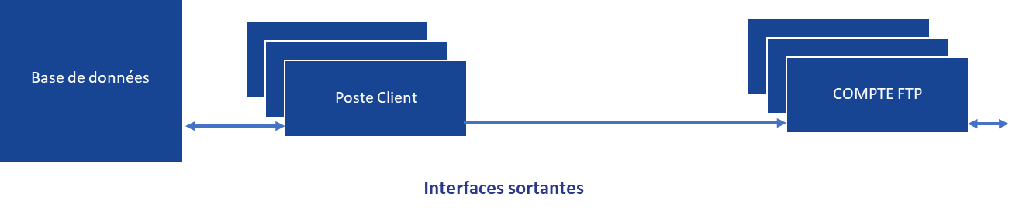
Outgoing interfaces
FTP ACCOUNT
Client computer
Database

Installation
The software suite is built on an environment that requires no additional frameworks, service packs or virtual machines. When an executable is copied to a computer, it can be run with any version of Windows supported by Microsoft (7 through 10).
The database is accessed via FireDAC and the configuration of an alias pointing to the database to be used.
Installing DIANE consists of:
- Copying executables and help files (2 GB)
- Configuring the alias
- Referencing DiaServeur (core of the application) in the Windows Registry
During the first installation, an MSI file (generic or adapted to your facility’s configuration) is provided to integrate all DIANE’s needs.
The computer is updated the first time DIANE is booted.
Higher permissions are not necessary for routine use. Only write permission in the DIANE installation directory is required (to write to the local cache).
All the modules are synchronized with DiaServeur.

Updates
DIANE supports an automatic update system in which packages hosted by a facility’s FTP server are retrieved.
The flows in purple are involved based on the data stored in the database and client computers search for any new versions that are available on the FTP server.

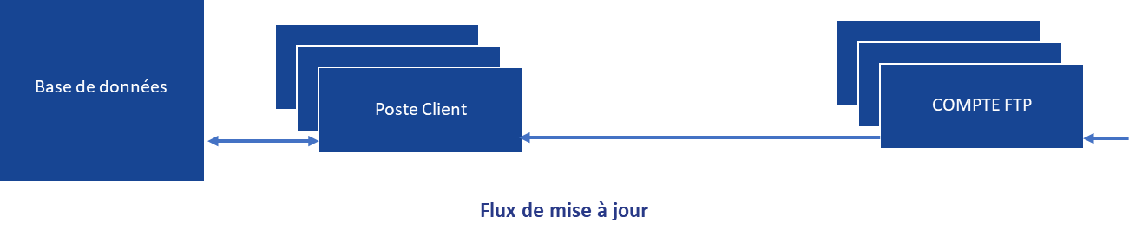
FTP ACCOUNT
Update flows
Client computer
Database
Multiple actions occur during an update:
- The database conversion tool (convertBD) is provided by Bow Medical and copied to the interface server. A special account is required to launch the tool. In the case of minor updates, users must have write permissions to the software installation directory and to the registry in Hkey_Current_User. Administrator permission is required in the case of major updates.
- Once executed, the convertBD tool updates the database and generates the package that is then placed on the FTP server to be downloaded by client computers.
In the case of a major update, this step may take several hours (four on average).
- Then, when DIANE is launched on a client computer (and depending on the data stored in the database), the DiaUpdate file is run silently to install the update and download new version files.
New versions can also be distributed electronically using standard off-the-shelf tools (such as SCCM).

Because only the application (executable files on client computers) is updated, minor updates are installed on the fly without having to stop any processes or shut down the database.
In addition, different minor versions may be run concurrently at the same facility. In this case users will see an alert informing them that an obsolete version is running each time a session is opened.
Major updates, which occur once every two years on average, entail converting the database. This means that the system will have to be shut down. This takes four hours (rarely longer) and can occur overnight (self-executing tool).

Workstations
Client computers connect to the database and feed and retrieve information needed by the user.
Using a MSSQL or MySQL database, connections to the database are made by a FireDAC alias.
An Oracle client must be installed on the client computer if an Oracle database is used.
PC setups must be conventional PCs with a Core i5 or Core i3 processor (with 2 MB cache), running Windows 7 or later, having at least 4 GB of RAM and a screen resolution of at least 1280 × 1024.
Desktop PCs are assumed to be already in place or to be provided and installed by you.

Architecture
When the application is launched, all configuration items and input catalogues (several tens of thousands of items) are updated in a local cache (encrypted files) and loaded into memory to make them instantly available. It stops querying the database for these items during the entire session (strong optimization of database resources and significant performance gains).

As indicated below, patient records and configuration data are loaded locally, which has significant advantages:
  - Fast execution times (no server querying)
  - Continuity of service in case the connection with the server is lost

DiaServeur

DiaServeur is the only module connected to the database (centralizes queries and manages DBMS differences).
Each DIANE module communicates via this DCOM server (Microsoft).
It distributes events by the sharing of ActiveX controls (object transmission).
These ActiveX controls are listed in the Windows Registry at each major update (integrated in the automatic update mechanism or manually by running DiaServeur.exe alone).
When a module (ICU, Consultation, Intraoperative, etc.) is booted, the first internal step is to check that DiaServeur is enabled. If it is not, the login window appears.
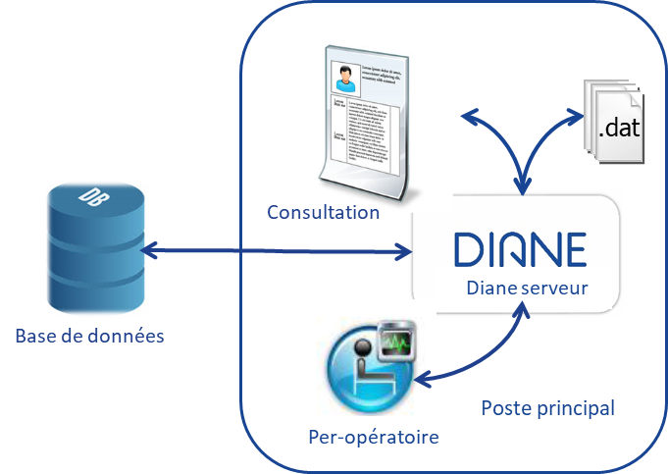
Main computer
Intraoperative
Database

Local cache
When a record is accessed, the patient’s data is temporarily loaded into the local cache (around 500 KB per surgery).
Changes to values are updated in the local cache and then written to the database.
If the database is not available, only the local cache will be used until the connection is restored.
When the database connection is restored, the local cache is synchronized and all local values are written to the database.

Primary computers
Primary computers are used for consultation purposes and are installed in various rooms (operating theatres, recovery rooms, ICU rooms, delivery rooms, etc.). They are connected to medical devices and patient records are locally loaded on them.

Secondary computers
Secondary computers are an important aspect of DIANE’s operation, for they:
- Allow wide freedom of choice when installing them in units
- Enable DIANE to be extensively customized to existing organizations

Because its operation is based on primary and mirror computers, DIANE is a powerful tool that allows all the patient records in a unit to be accessed in read/write mode simultaneously by multiple users. Secondary computers may be computer sets running conventional operating systems or Citrix.
In ICUs, these computers are generally located in medical offices, central nurses’ stations, first-aid rooms, secretariats, offices of hospital executives, etc.
In anaesthesia settings, they are generally used in the recovery room when computers running DIANE cannot be installed above patients’ beds. Primary computers are installed at nurses’ stations (they are stationary and manage a set number of beds). Secondary computers are installed on trolleys. All recovery records are accessible from any secondary computer.
Data that is changed on any of these computers is populated to the others in real time.
For instance, two users can work on the same part of the application at the same time without ever negatively affecting the information displayed.
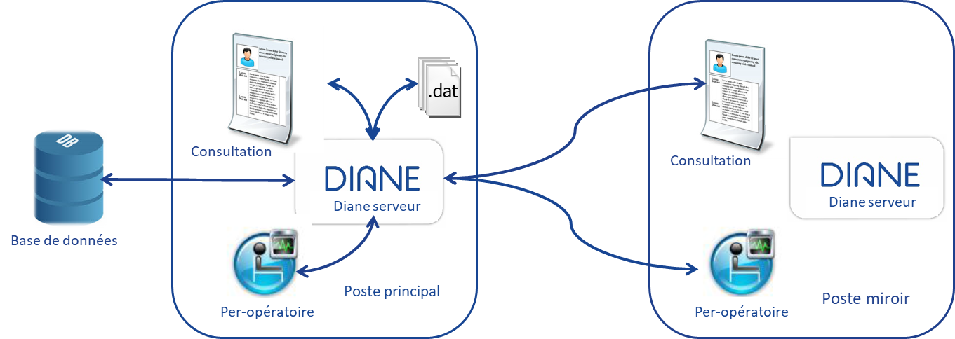
Intraoperative
Intraoperative
Mirror computer
Main computer
Database

All changes made by users can be identified by their logins and change events are shared across all active client computers.
Remote connection is separate from access to the database (offline mode available) and enables users to access remote records even during maintenance and incidents on the database server.
Only edited data pass from one computer to another without users having to refresh displayed pages (push method) and there are no imposed refresh intervals. DiaServeur reports new information to the client computers.

Depending on the setup and users’ permissions, all records opened in an OS, RR, CCU and ICU can be accessed from a mirror computer:
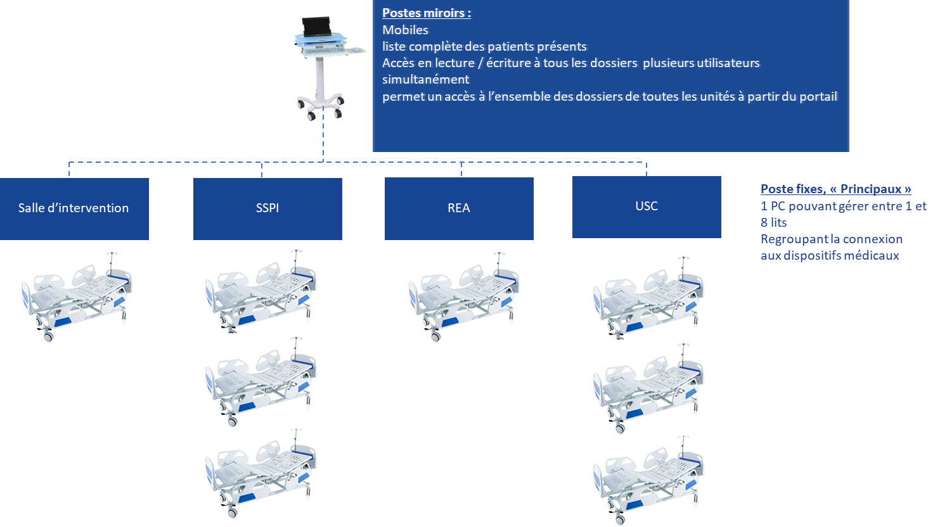
‘Main’ desktop computers
One PC that can manage up to eight beds
Pools the connection to medical devices
Mirror computers:
Mobile
Full list of hospitalized patients
Read/write access to all records for multiple users simultaneously
Gives access to all records for all units from the portal
CCU
ICU
Recovery
Operating theatre

Technical overview of mirror computers
Remote operation uses DCOM (Distributed Component Object Model), a proprietary Microsoft technology for remote access. In the illustration below, computer A is connected as a mirror to the record already open on computer B. The installation of computers A and B is identical, but computer B has control over the record. All computers wishing to access the record may do so only as secondary computers.
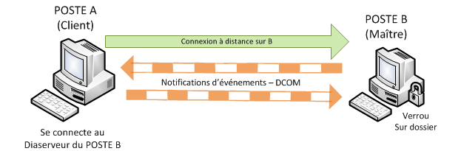
Event notifications – DCOM
Remote connection to B
Connects to Diaserveur on COMPUTER B
Lock on record
COMPUTER B
(primary)
COMPUTER A
(client)
Our prerequisites for using DiaServeur remotely (and thus DCOM) are as follows:
- The firewall must be configured to allow this type of connection and certain user permissions must be enabled on the primary computer (TCP port 135, allow DIANE executables).
- The user in question is the person on the secondary computer. We assume that this user has restricted (non-administrator) permissions. We also assume that the person using the primary computer has permission to boot DIANE (and thus DiaServeur).
- The person using the secondary computer must be able to remotely access and enable (but not run) COM objects on the primary computer.

Loading of records
To enter information into a patient record from a secondary computer, users must open the record in the list of currently admitted patients.
The following elements have been integrated to reduce loading times (a few seconds):
- Data are not retrieved from the database but from one computer to another via the transfer of a preformatted binary file. This optimizes the volume to be transferred and the time required to process a large amount of information. Data are displayed without any query processing.
- Only data from the last 48 hours (medication orders, care plan, views, etc.) is displayed first. If a user needs to see more data, they will progressively be loaded as a background task.

Installation in units
Computers for operating theatres, recovery rooms, ICUs and induction and delivery rooms are optional. They consist of medical-grade panel PCs that comply with both hygiene standards (IP65 screens that can be cleaned with conventional disinfectants) and electrical safety standards and are anchored in operating suites (IEC-601-1 standard). Washable antimicrobial keyboards and conventional optical mouses are usually offered as a first choice. Sealed medical-grade keyboard and mouse combos, which are also cleanable, are preferable however.
Each PC set and central printer must be fitted with a port for connecting to your facility’s main network. Mains sockets for plugging in the various hardware are required.
For improved hygiene, we recommend using either sealed antimicrobial keyboard and sealed medical-grade mouses or medical-grade keyboard and mouse combos.
Word must be installed on each PC and the server in order to print out form letters. The facility is responsible for supplying and installing Word.

ICU rooms
These panel PCs must be mounted on arms fitted with a foldaway keyboard and mouse combo. In the vast majority of cases, these arms are mounted to a wall or a ceiling.
Connection to medical devices will be made via Ethernet serial port servers placed at the heads of patients’ beds. Equipment placed near a panel PC may also be connected directly to it.
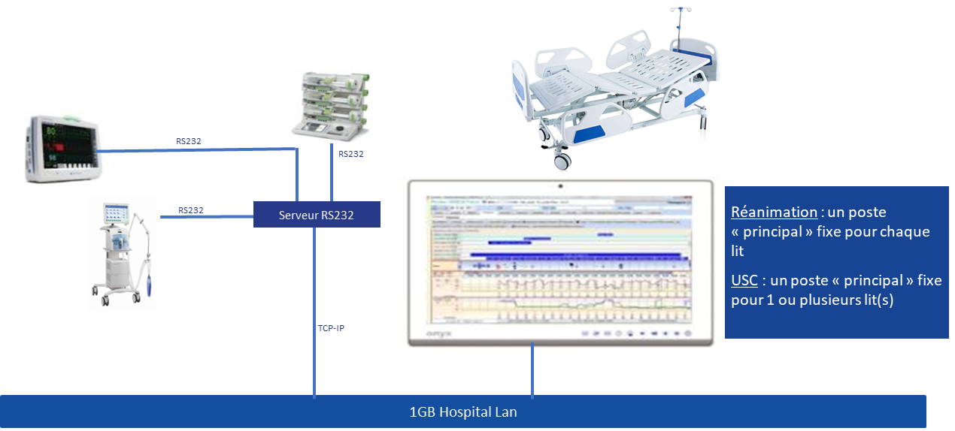
RS-232 server
ICU: a ‘main’ desktop computer for each bed
CCU: a ‘main’ desktop computer for one or more beds

This requires having two network points in each room (one for the computer and one for the serial port server). An alternative solution is retrieve HL7 data from vital-sign monitors over the network. However, all the monitors must be of the same brand and connected to a central patient monitoring system. In this case, the facility will have to purchase the corresponding HL7 service from the supplier of the biomedical devices and we will need to set up our own HL7 service on a secure Windows Server supplied by us.

CCUs
We recommend the same installation as in an ICU room.
The only difference is that, as there may be as many as three patients in a room, one PC can be used to manage all the beds in it.
It is also possible to install the PCs outside the rooms, in which case each DIANE computer can manage up to eight CCU beds.

Operating theatres
We generally recommend installing DIANE panel PCs on one side of the anaesthesia workstation to facilitate access by anaesthesia teams. They are mounted on an arm with a keyboard and mouse platform. Depending on the anaesthesia workstation, adapters may be used to secure the arm to a ventilator.
Because anaesthesia workstations are moved around and placed in various positions, this solution reduces both the length of RS-232 and network cables and the need to handle them.
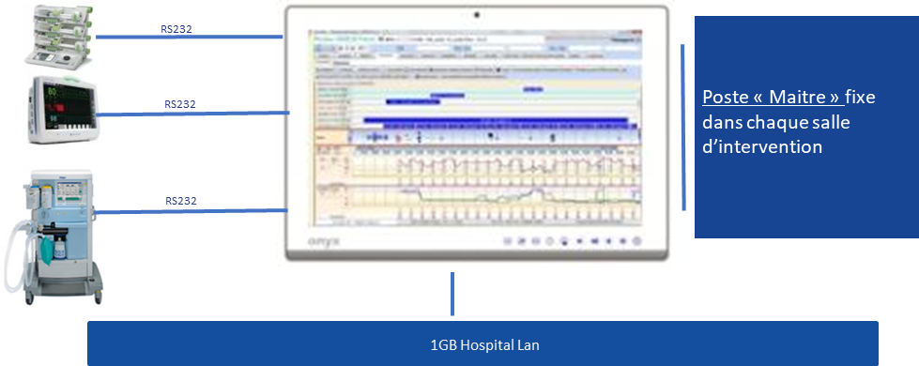
A ‘main’ desktop computer in each operating theatre

Other installation configurations are possible in operating theatres, particularly when they have ceiling pendants on which ventilators are mounted. In this case, we suggest mounting the panel on a ceiling pendant and, depending on their position, connecting the medical devices either directly (RS-232) or via a serial port server..

Recovery rooms
Multiple installation configurations are possible in recovery rooms. Below are two of our preferred configurations:
- Arm-mounted panel PCs mounted directly above beds (one for two beds, for example). In this case, biomedical devices will be connected directly to the PC panels.
Each PC panel must therefore have a port for connecting directly to your facility’s main network. The advantage to this solution is that it allows data to entered right at a patient’s bedside and the connection of other types of biomedical devices such as multi-parameter vital sign monitors. Its main drawbacks are that more PC sets are needed and medical-grade panel PCs, which are more expensive than conventional desktop PCs, must be used.

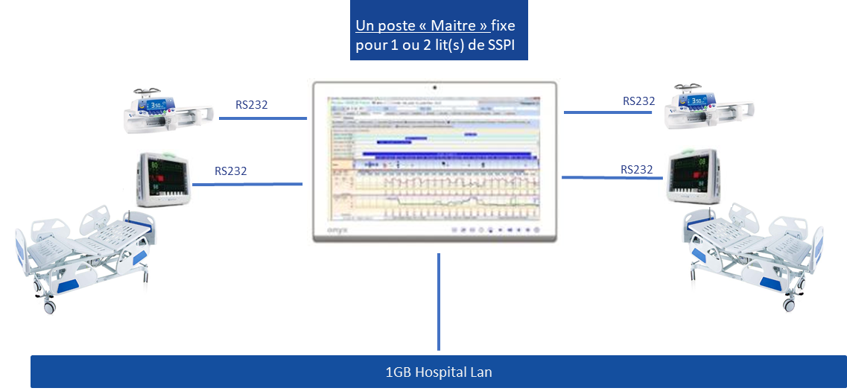
A ‘main’ desktop computer for up to two RR beds

- Another solution is to install conventional desktop PC sets at the nurses’ station and have each set manage up to eight recovery beds depending on the case. Serial port servers for connecting medical devices, as well as ports for connecting to your facility’s main network, will have to be installed at the head of each bed.
A two or four-channel converter will be necessary to connect a ventilator or other kine of biomedical device (such as a PCA pump) in addition to the monitor. An alternative solution is retrieve HL7 data from vital-sign monitors over the network. However, all the monitors must be connected to a central patient monitoring system. In this case, the facility will have to purchase the corresponding HL7 service from the supplier of the central monitoring system and we will need to set up our own HL7 service.
We will then round out the installation with mobile ‘secondary’ workstations that can access the records of all RR patients in read/write mode. They can be connected to the Wi-Fi network and placed on trolleys.
The advantage to this solution is that it fewer PCs need to be installed and they can be conventional PC sets.

Connection to medical devices
DIANE currently has drivers for 420 biomedical devices including monitors, ventilators, syringe pumps, infusion pump stations, haemofiltration devices and haemodynamic monitor systems.
Because Bow Medical develops its own drivers, we do not need any outside assistance to deploy and install DIANE. In addition, our own teams perform maintenance on the connection to keep it up and running.
If you so require, Bow Medical can also contact a biomedical EAI to set up the connection with your medical devices.
DIANE can use either the RS-232 outputs on devices (depending on availability, additional manufacturer options may be required) or network communication ports.
Network communications can occur either ‘directly’ (devices directly send HL7) or via an HL7 gateway provided by the manufacturer (proprietary communication protocol between devices and the gateway that transfers HL7 files and whose cost must be taken into consideration).
Having this proprietary network protocol for some manufacturers, we are also able to provide the equivalent of this gateway and allow direct connection.
Generally speaking, we favour the most direct connections possible either via RS-232 cable or by via second network adapter dedicated to autonomous monitors (not dependent on a gateway).

One facility, multiple solutions
Facilities may choose to implement multiple solutions.
Each solution has its own advantages and disadvantages, and the right one for you will depend on your environment.

List of possible connections:
- Direct RS-232 connection to panel PCs
  - This solution is used when devices are located near DIANE computers, which is generally the case in the operating theatres and recovery rooms.
- Smart cables: by adding a USB/RS-232 converter to a conventional cable, connected devices can be detected automatically.
  - Smart cables are particularly used for mobile medical devices (infusion, haemodialysis, PiCCO, etc.) and we suggest using them. When they are plugged in to a computer’s USB port, DIANE will be able to automatically detect the type of device. This eliminates the need for users to set up DIANE to indicate which device is connected, saving them valuable time and improving system security.
- USB connection (direct connection): if a DIANE computer does not have enough serial or HL7 ports, a converter can be used to enable us to connect to a USB port whilst simulating a serial port or a network adapter.
- Serial port server (for connecting devices to an RS-232 hub)
  - This solution is mainly used in recovery rooms and ICUs. We opt for it when DIANE computers are located far from devices and direct connection is not possible. In this case, biomedical devices are connected to a serial port server which is itself connected to the hospital network. Connections between DIANE client stations and the serial port server are made directly over the hospital network by simulating a COM port. This solution also allows conventional client computers that lack serial ports to be used.
- HL7 gateway (for connecting monitors via a central patient monitoring system)
  - When monitors are connected to a central patient monitoring system, we can connect to that central system. If ventilators are connected to the monitors, we can also collect ventilator fan data via the central system. This solution avoids having to add (sometimes) expensive options to monitors in order to be able to communicate via RS-232. The central patient monitoring system exports the HL7 files to our interface service, which processes the data and then dispatches them to the client computers to be added to patient records.
- HL7 direct connection: if your devices export HL7 data directly, we can connect them directly to a second network adapter on a panel PC.
- Wi-Fi connection: if your devices export HL7 data directly over Wi-Fi, they can be connected to DIANE computers via a Wi-Fi adapter.

DIANE side
There are three groups to consider on the DIANE side:
- Direct RS-232 or HL7 connection: devices are directly connected to workstations, eliminating the need for hubs or network configuration. Direct connection can be made:
  - Via a COM port on the computers
  - Via an additional network adapter
  - Via a USB adapter
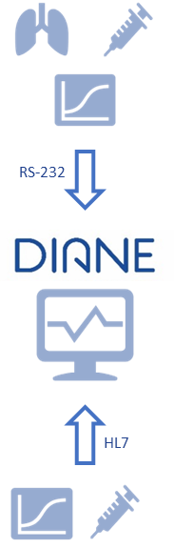

- Remote RS-232 connection via hubs placed near devices (IP configuration required).
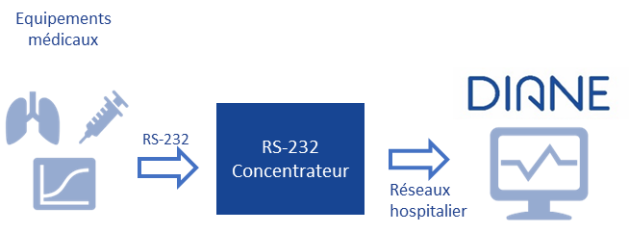
RS-232
Hub
Hospital network
Medical devices

- Network HL7 connection via a central patient monitoring system or biomedical EAI
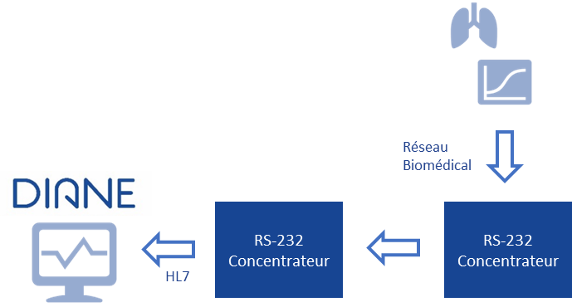
RS-232
Hub
RS-232
Hub
Biomedical network

The closer the solution is to workstations (fewer intermediates devices and systems), the simpler interventions will be:
- The configuration, especially when replacing networked devices
- Stability: fewer intermediates devices and systems (hubs, gateway, network)
- Cost: all intermediates devices and systems entail additional costs

In the case of direct connection, we recommend optically isolating the ports if the serial outputs of biomedical devices are not already isolated. Similarly, an isolation transformer is recommended for any non-medical-grade PCs located in patient environments.
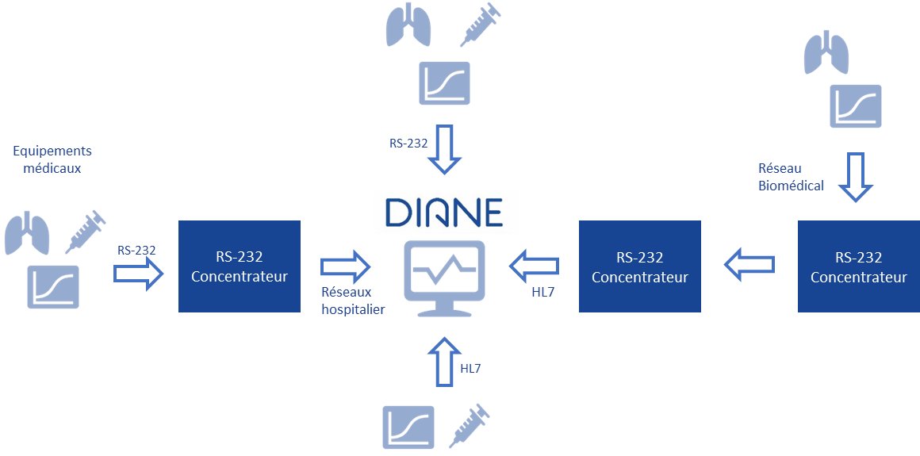
RS-232
Hub
Biomedical network
Medical devices
Hospital network
RS-232
Hub
RS-232
Hub

Connection type | Advantages | Disadvantages
Direct RS-232 | Inexpensive solution  Simple setup  Reliability in case of network failure  Network points not required  Short cable if the computer is next to the device | A cable is required for each connected device  Specific cables required  Medical-grade panel PCs required
Remote RS-232 | Suitable in many situations  Unlimited distance between devices and PC  Small hub  Use of Citrix possible | Expensive solution (one hub per computer)  Complex setup (each device must be configured separately)  No data retrieval in case of network failure (on switch in question)  Additional mains socket required  Additional network point required  There must be enough ports for future needs  Specific cables required  Devices cannot be moved around without reconfiguring the ports  A cable is required for each connected device
Network HL7 | Inexpensive if monitoring system already installed  No new cables  No mains socket required  Use of Citrix possible | No data retrieval in case of network failure  Devices cannot be moved around without reconfiguring the network (depending on device)  Expensive if monitoring system not already installed  Maintenance by software company and manufacturer at the same time (longer resolution time)  Depending on the manufacturer, data cannot be retrieved from all types of device  No alarm retrieval
Direct HL7 | Inexpensive solution  Simple setup (each monitor must be configured with the same IP address)  Reliability in case of network failure (direct connection)  Additional network points not required  No mains socket required  Mobile devices possible  Devices and PC may be located several metres apart  Standard network cables | PC must have two network adapters  Devices must be compatible with it (rare)  Citrix/TSE not possible

OFFLINE MODE/CONTINUITY OF SERVICE
This aspect is one of DIANE’s strengths.
DIANE features failovers that ensure continuity of service in the event of a server failure or, as is more common, network problems. If such issues occur, the client computer fails over to local mode. Data from biomedical devices continues to be collected and sent to all computers without any problem (provided they are directly connected) and users continue to be able to enter information in patient records.
Operation in offline mode continues even if DIANE or a computer is stopped and rebooted. Only data that must be retrieved from the server or via the network will be affected. Users are informed by a message on the screen and by a change of background colour.
This is why we remain a client/server application.
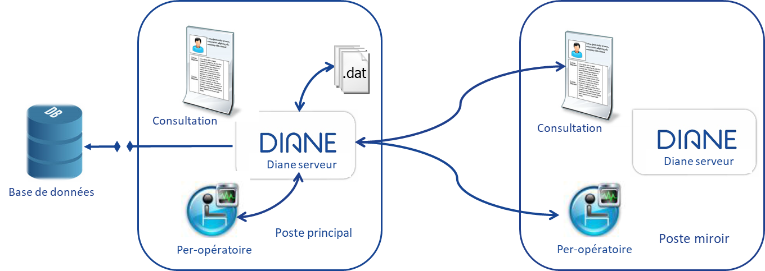
Each time a patient record is closed, a new patient record is opened or a user moves from one tab to another, DIANE checks if it has access to the database hosted on the server. If so, DIANE will resynchronize all patient records acquired in local mode using the same mechanisms as those in place for preoperative assessment or consultations conducted at a patient’s bedside in offline mode and data post-synchronization.
Mirror computer
Intraoperative
Main computer
Intraoperative
Database

When the application is launched, all configuration items and input catalogues (several tens of thousands of items) are updated in a local cache (encrypted files) and loaded into memory to make them instantly available. It stops querying the database for these items during the entire session (strong optimization of database resources and significant performance gains).
When a record is accessed, the patient’s data is temporarily loaded into the local cache (around 500 KB per surgery).
Changes to values are updated in the local cache and then written to the database.
If the database is not available, only the local cache will be used until the connection is restored.
When the database connection is restored, the local cache is synchronized and all local values are written to the database.

Client computer
If a client computer fails during online mode, DIANE may be accessed on a backup computer or any other available computer. At boot, a message will ask for the user’s location. The user simply has to enter the location of the failed computer. DIANE will then automatically open the record of the patient being monitored there. All the data that had been entered prior to failure as well as the location’s configuration environment will be displayed.

SOFTWARE PROTECTION
In accordance with prevailing legislation including Title 5 of French Act 85-660 of 3 July 1985, Bow Medical represents its desire to maintain and preserve its rights to the software provided and to the documentation. Its source codes and all associated documentation are regularly registered with the French APP Agency for the Protection of Programs (APP).
All right to the software and its documentation shall remain with the Supplier.
The facility purchasing the operating licence shall undertake to protect the software and copies thereof so as to uphold the Provider’s rights. It also undertakes to reproduce the Provider’s copyright notice as well as IDDN number fr.001.440010.00.S.P.1999.000. 31230 on all documents that it may create.

Copyright
The Software and all rights, without limitation including proprietary rights and intellectual property rights thereto are owned by Bow Medical. Bow Medical is protected by international treaty provisions and by all other applicable national laws of the country in which the Software is being used. The structure, organization and code of the Software are the valuable trade secrets and confidential information of Bow Medical. Any copies which you are permitted to make pursuant to this Agreement must contain the same copyright and other proprietary notices that appear on the Software. If you reverse engineer, reverse compile, disassemble or otherwise attempt to discover the source code of the Software, in breach of the provisions of this Agreement, you hereby agree that any information thereby obtained shall automatically and irrevocably be deemed to be transferred to and owned by the Provider in full, from the moment such information comes into being, notwithstanding the Provider’s rights in relation to breach of this Agreement.
The facility or software company purchasing the operating licence shall undertake to protect the software and copies thereof so as to uphold the Provider’s rights. It also undertakes to reproduce the Provider’s copyright notice as well as IDDN number fr.001.440010.00.S.P.1999.000. 31230 on all documents that it may create.

Restrictions to rights
You may not copy, distribute, extract components or make derivative works of the Software. When using the Software, you must comply with the following restrictions:
(a) You may make one copy of the Software on a permanent storage medium as an archival backup copy, provided this archival backup copy is not installed or used on any computer. Any other copies you make of the Software shall constitute breach of this Agreement.
(b) You may not use, modify, translate or reproduce the Software or transfer rights to use the Software or copies thereof in any manner other than as provided for in this Agreement.
(c) You may not sell, sub-license, lease or rent the Software or use the Software for the provision of commercial services.
(d) You may not reverse engineer, reverse compile or disassemble the Software or otherwise attempt to discover the source code of the Software, except to the extent that this restriction is expressly prohibited by law.
(e) You agree that you will only use the Software in a manner that complies with all applicable laws in the jurisdiction in which you use the Software, including, but not limited to, applicable restrictions concerning copyright and other intellectual property rights.
(f) You agree that you will only use the Software and its functions in a way which does not limit the possibilities of other End Users to access these services. The Provider reserves the right to limit the scope of services provided to individual End Users, to enable use of the services by the highest possible number of End Users. Limiting the scope of services shall also mean complete termination of the possibility to use any of the functions of the Software and deletion of Data and information on the Provider’s servers or third-party servers relating to a specific function of the Software.

Reservation of rights
Bow Medical hereby reserves all rights to the Software, with the exception of rights expressly granted to the end user of the Software.
FTP account

